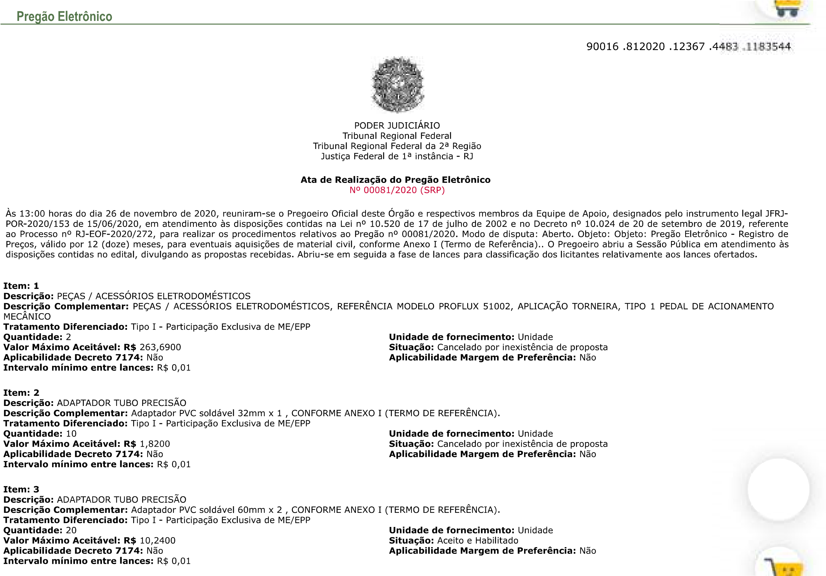
JFRJEOF202000272V01
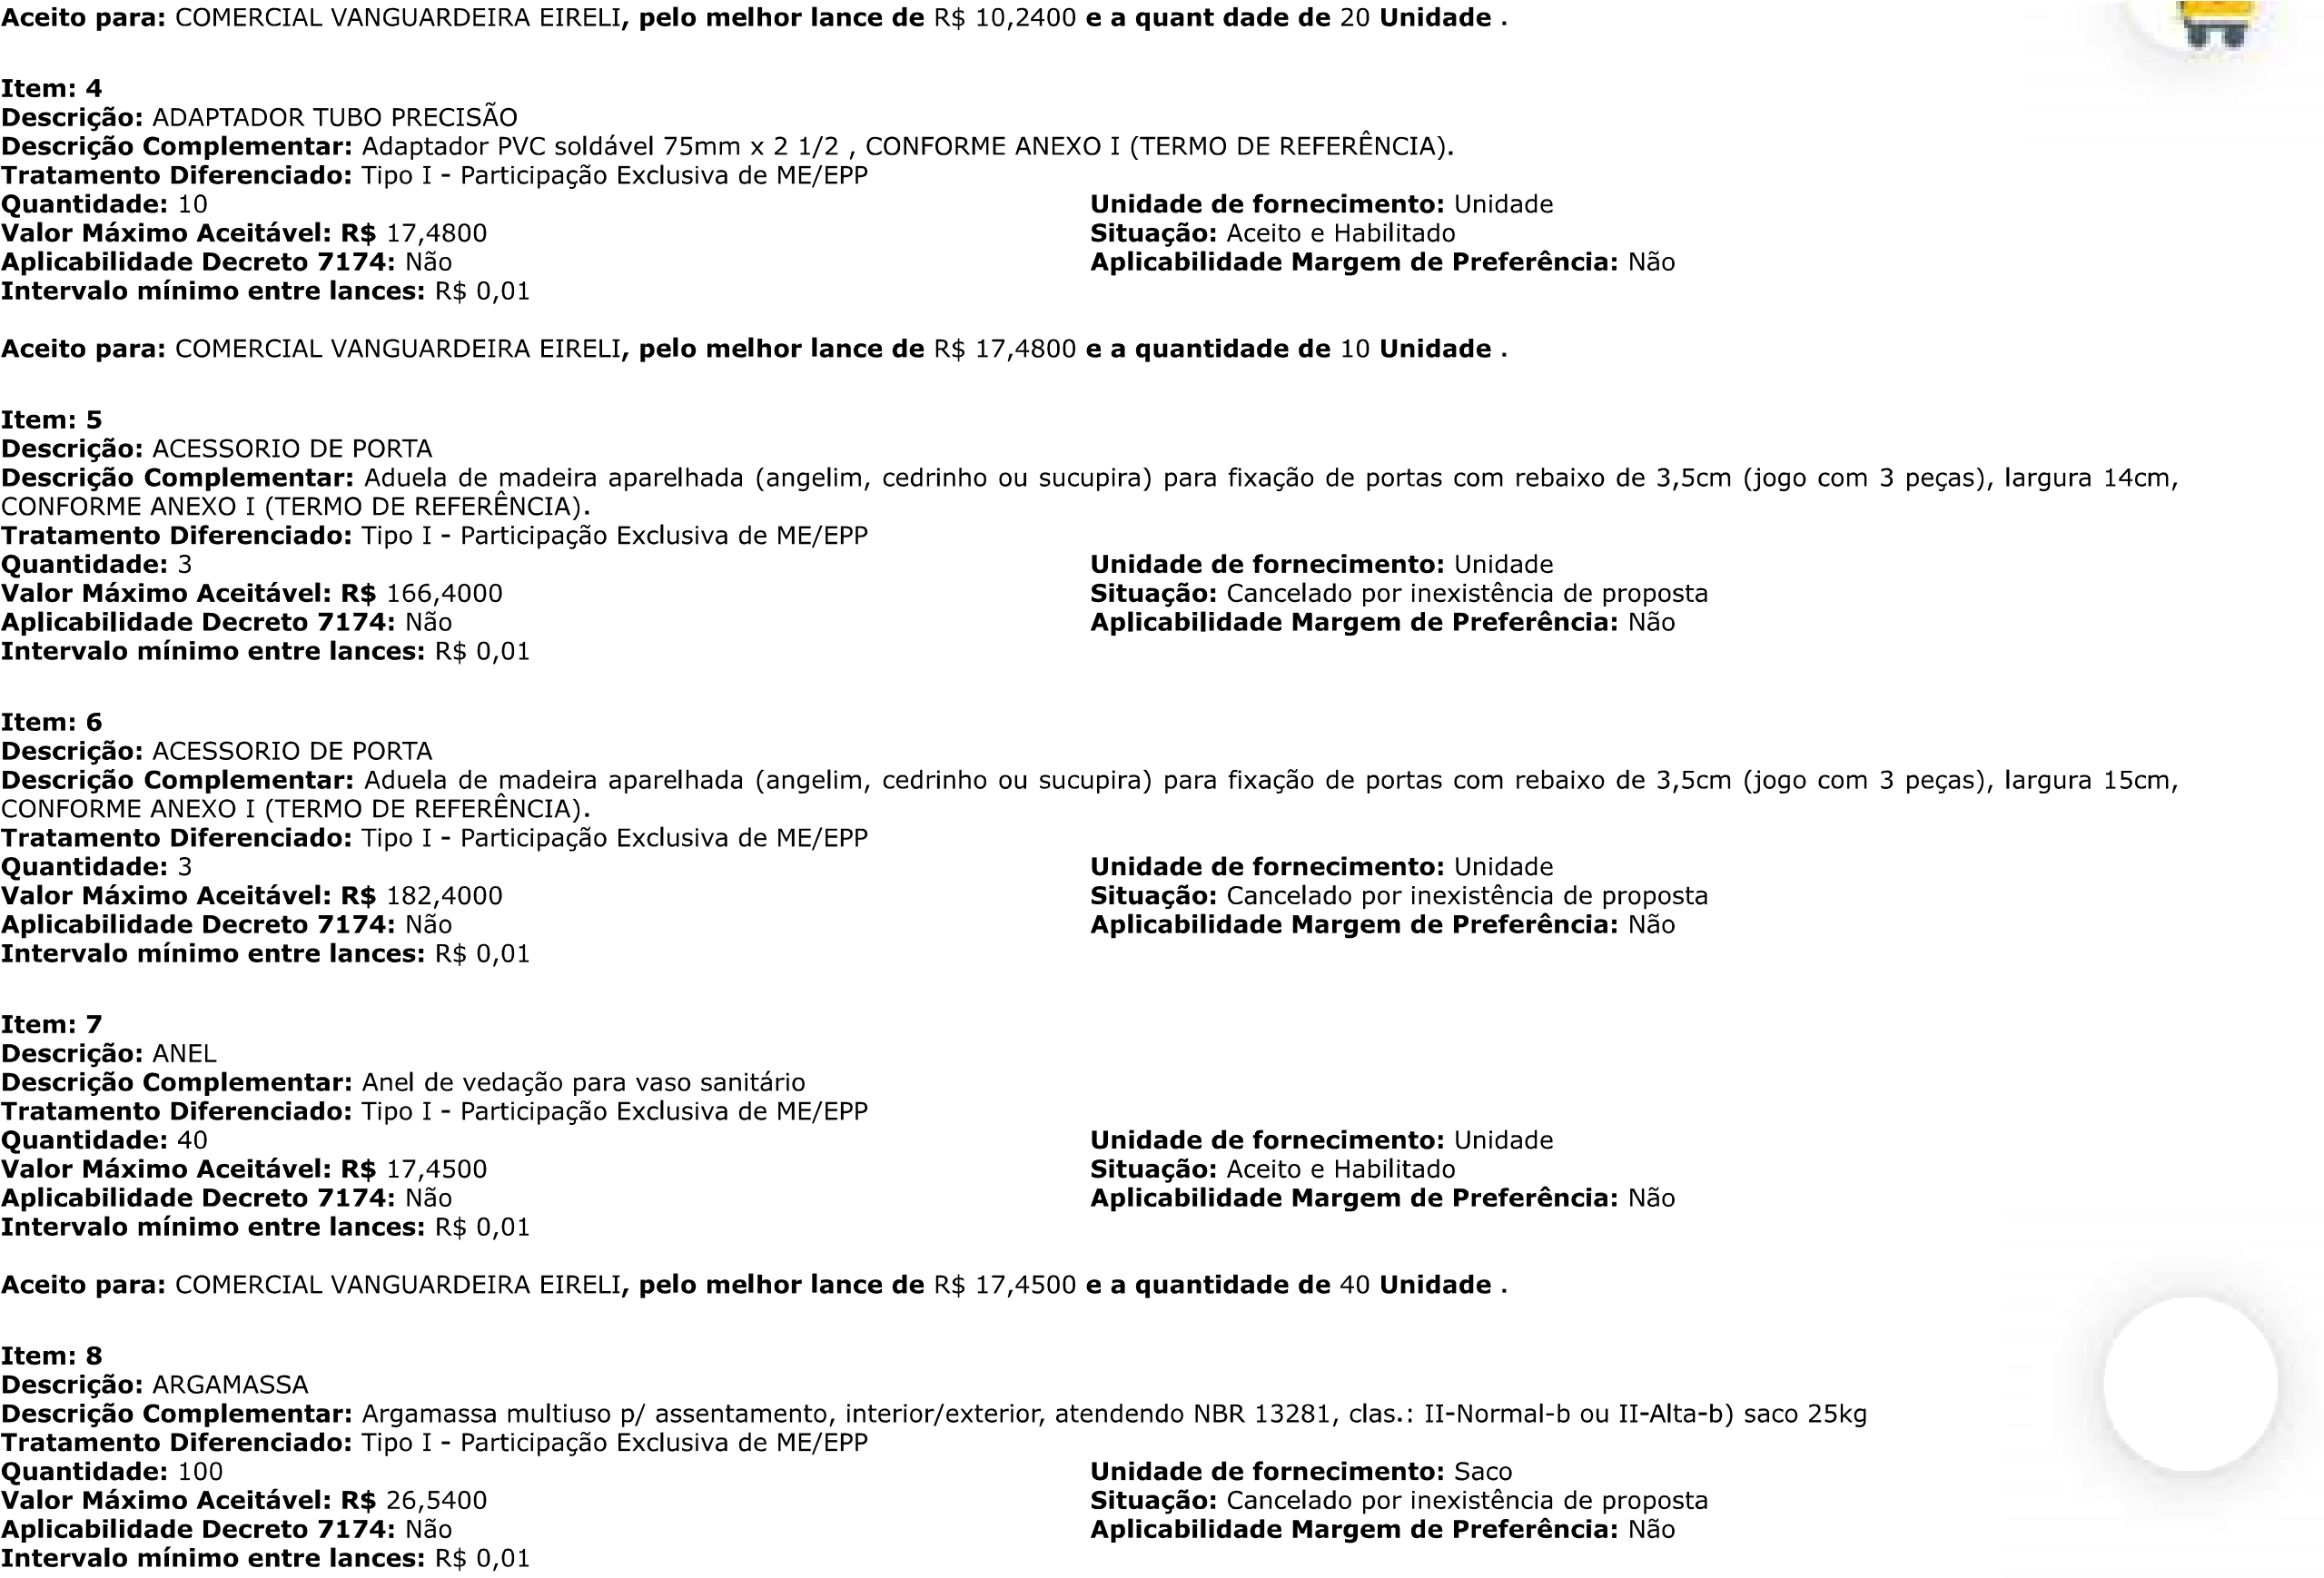
JFRJEOF202000272V01
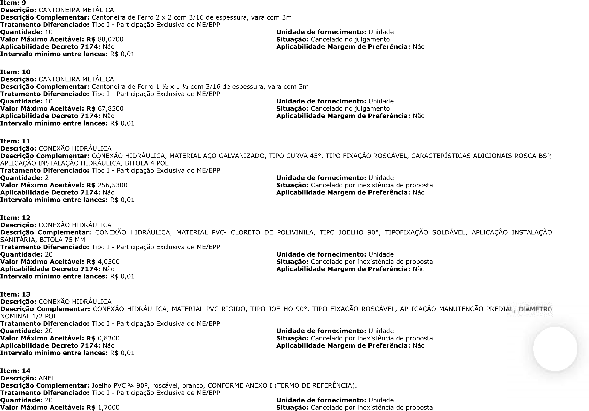
JFRJEOF202000272V01
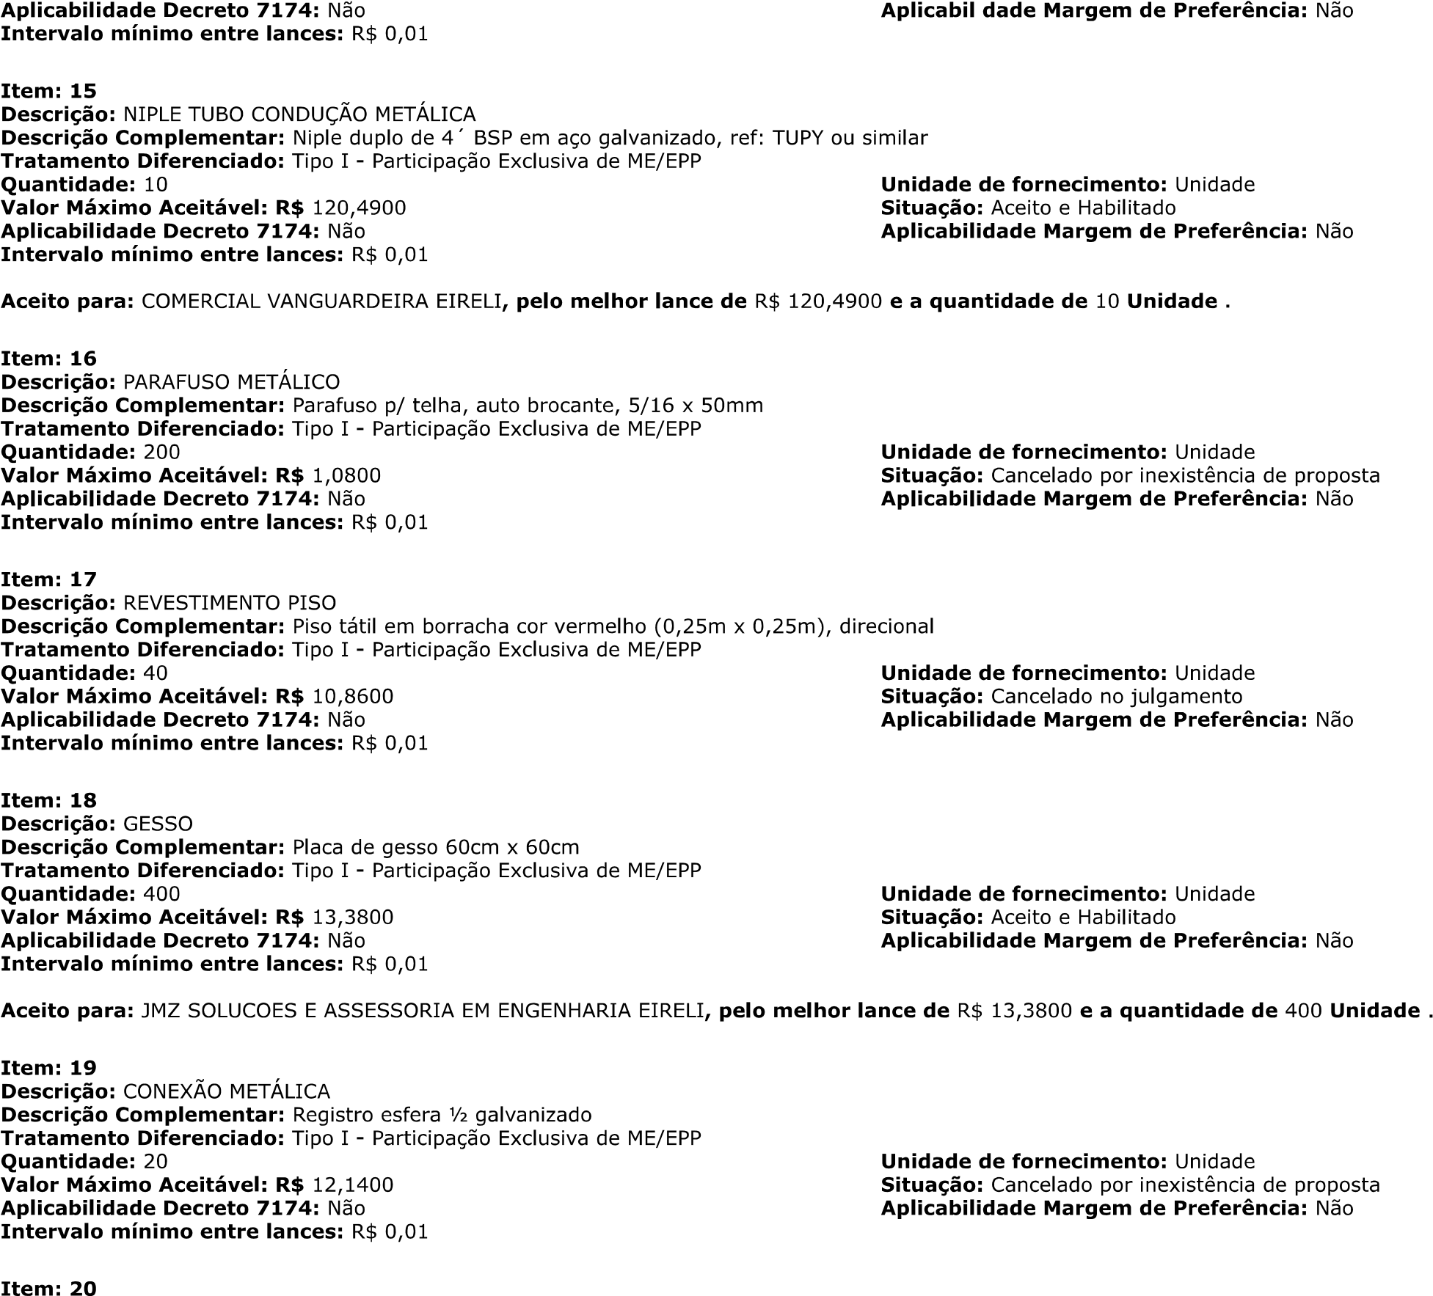


JFRJEOF202000272V01
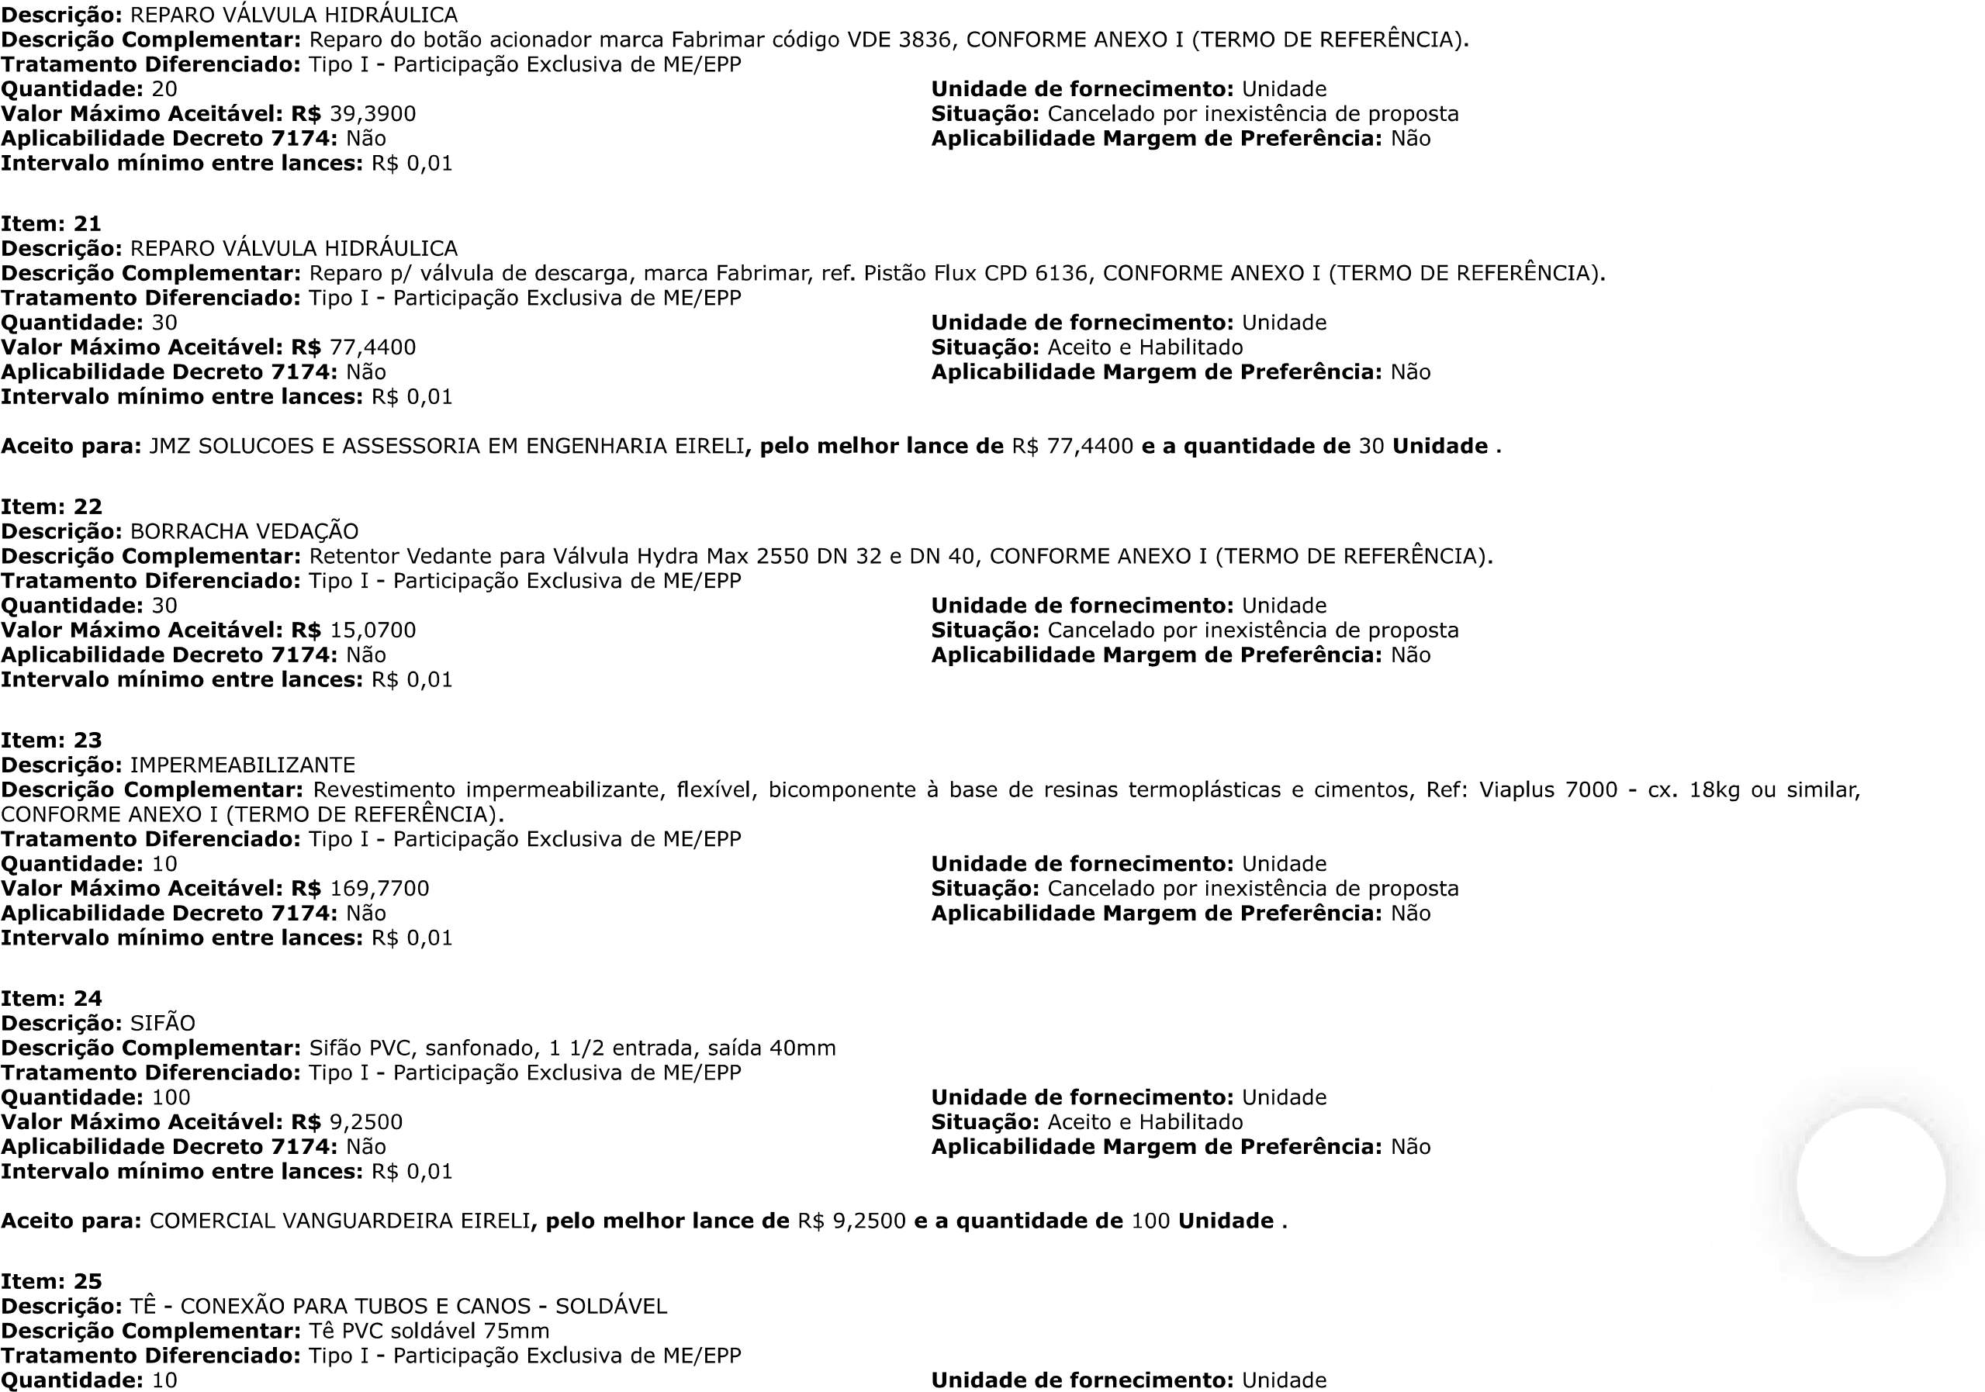
JFRJEOF202000272V01
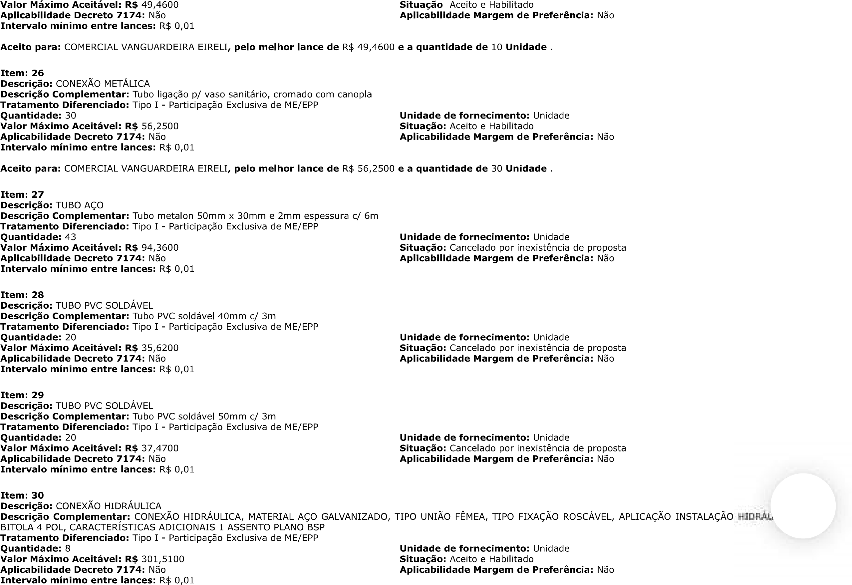
JFRJEOF202000272V01
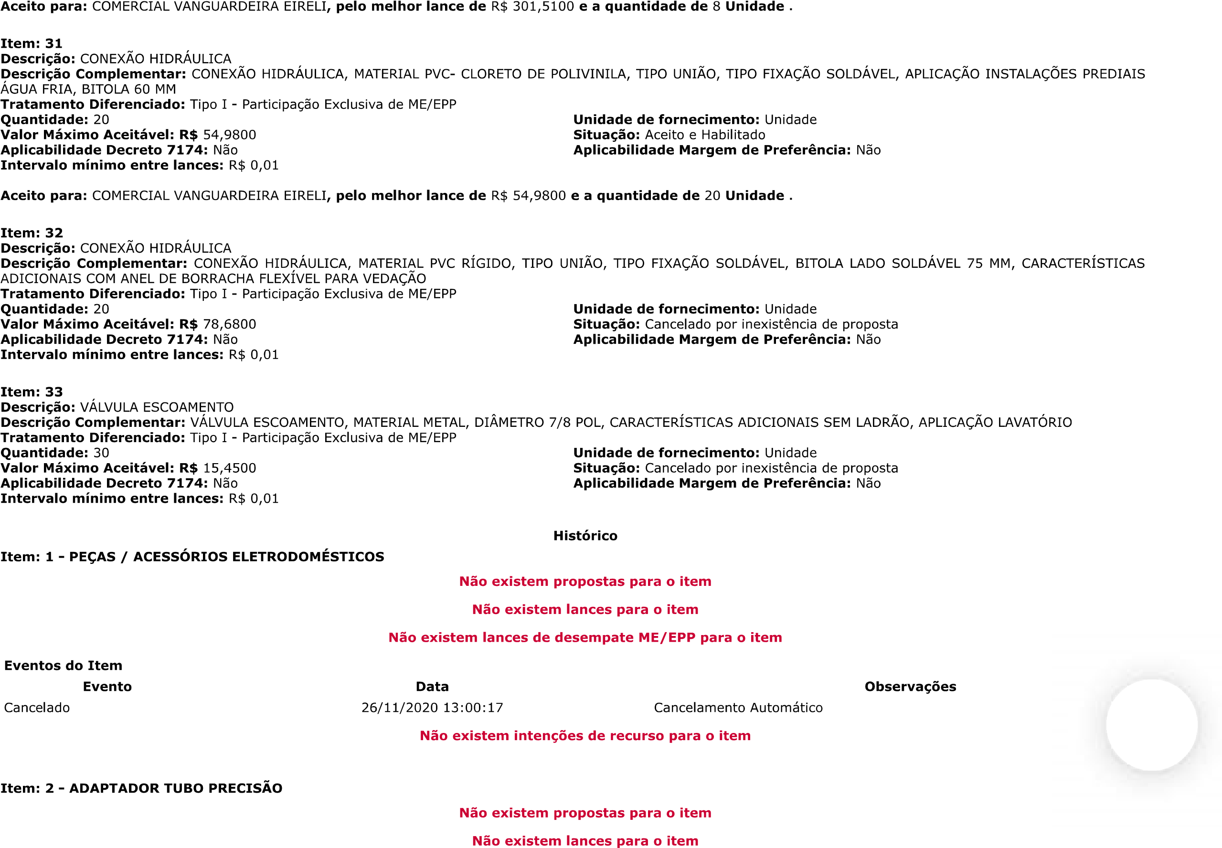
JFRJEOF202000272V01

JFRJEOF202000272V01
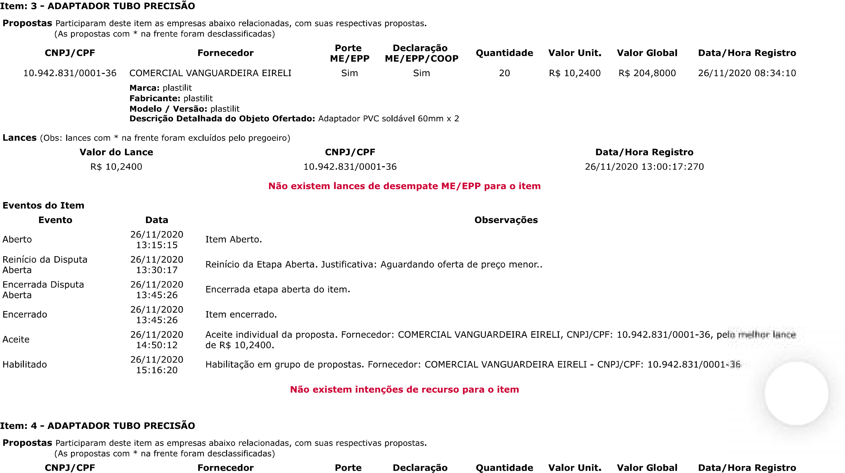
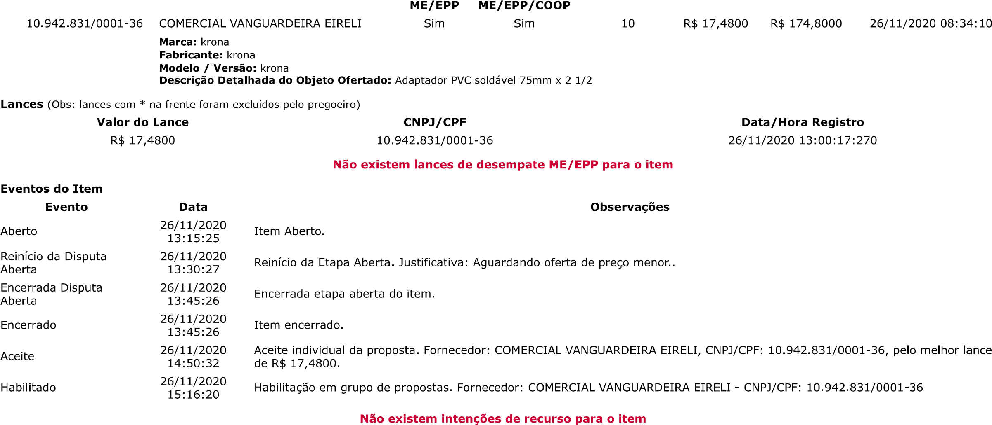
JFRJEOF202000272V01

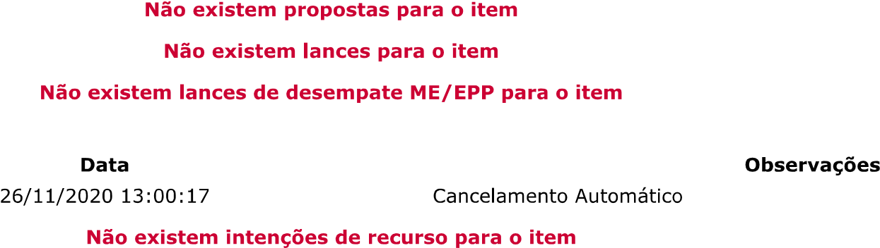

JFRJEOF202000272V01
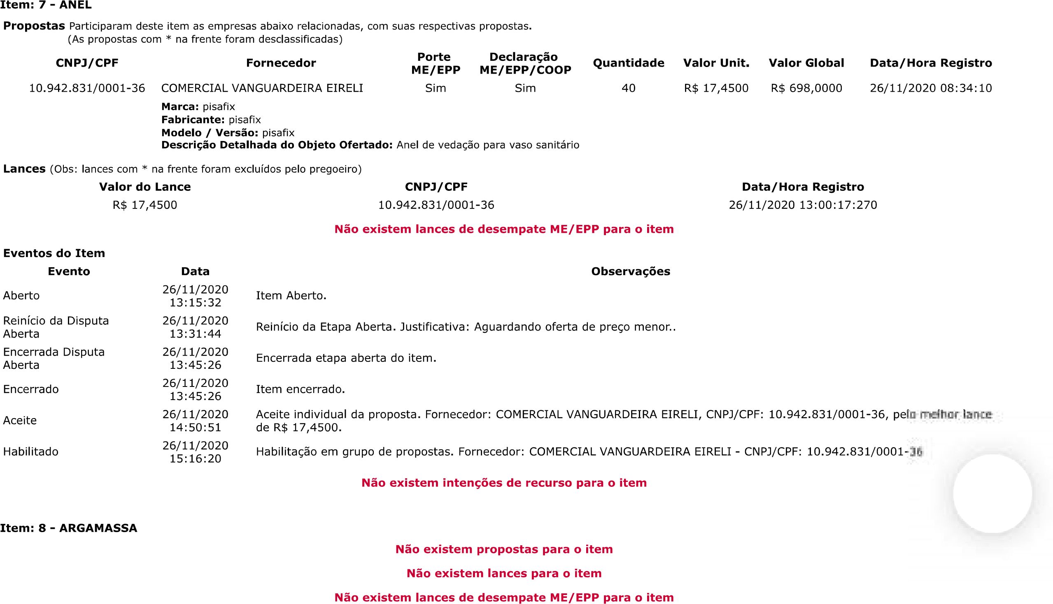

JFRJEOF202000272V01
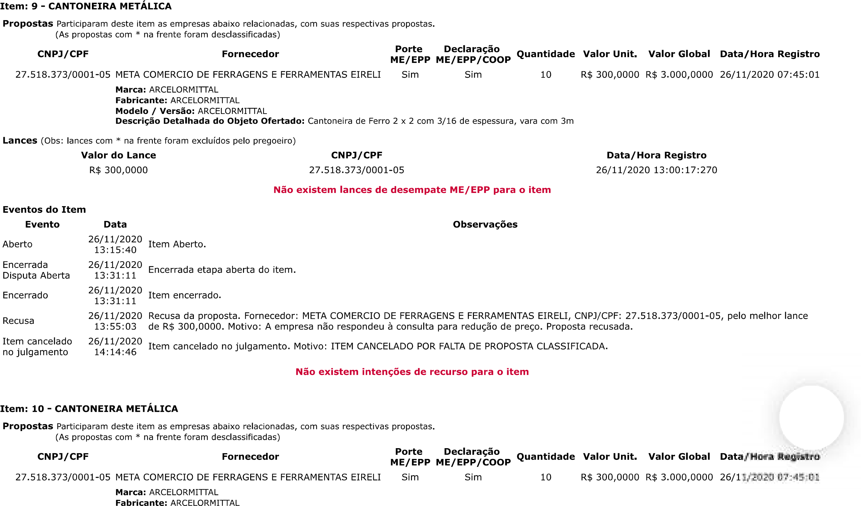
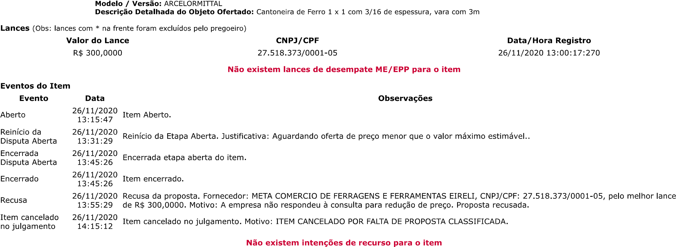
JFRJEOF202000272V01

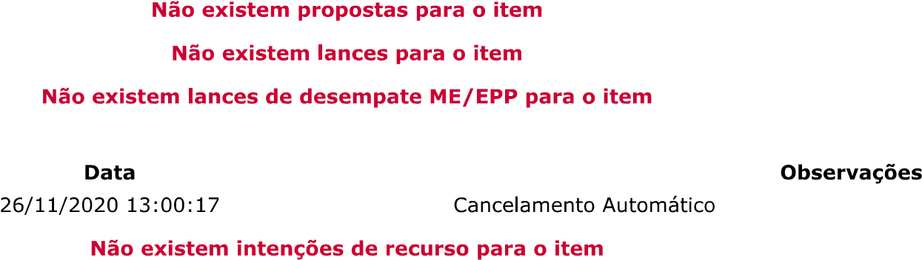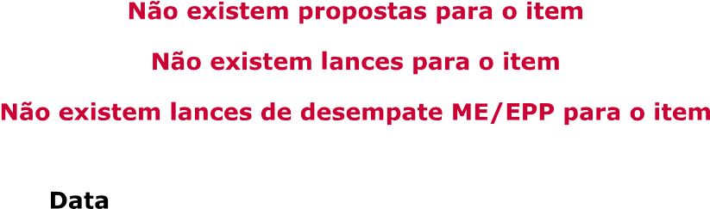
JFRJEOF202000272V01

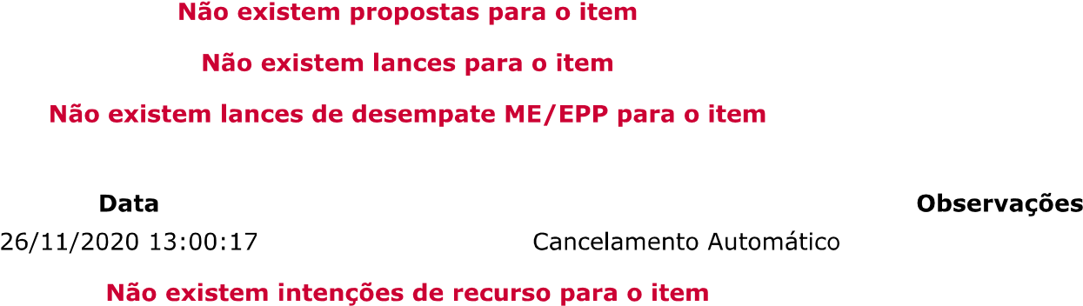

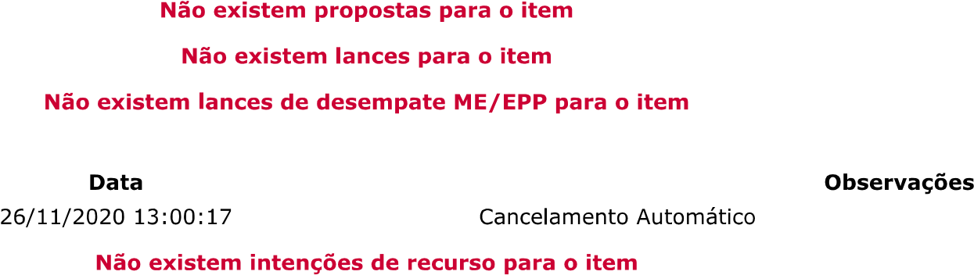
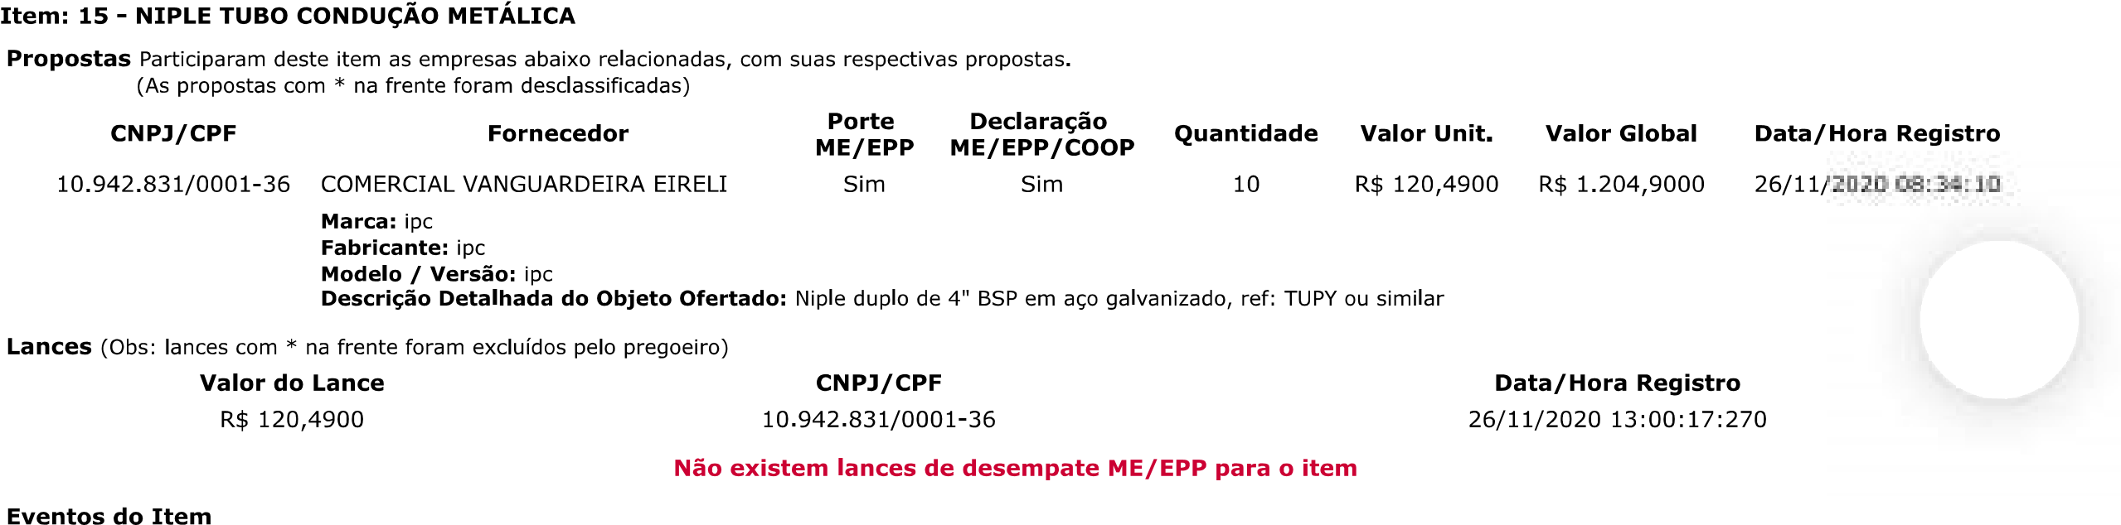
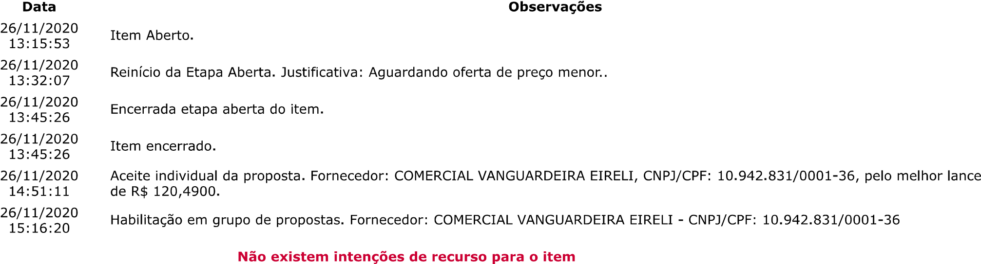
JFRJEOF202000272V01

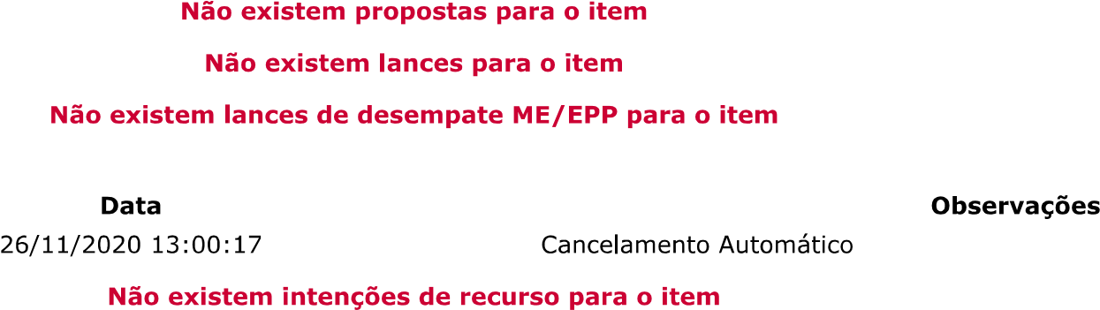
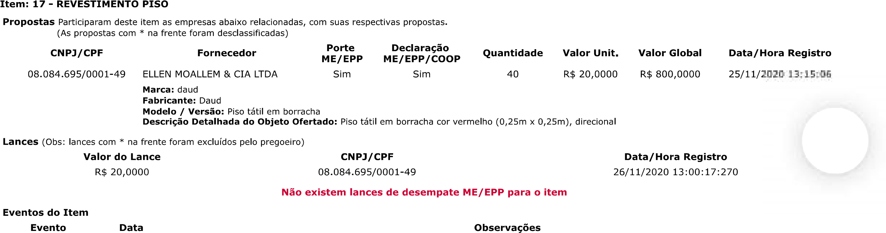
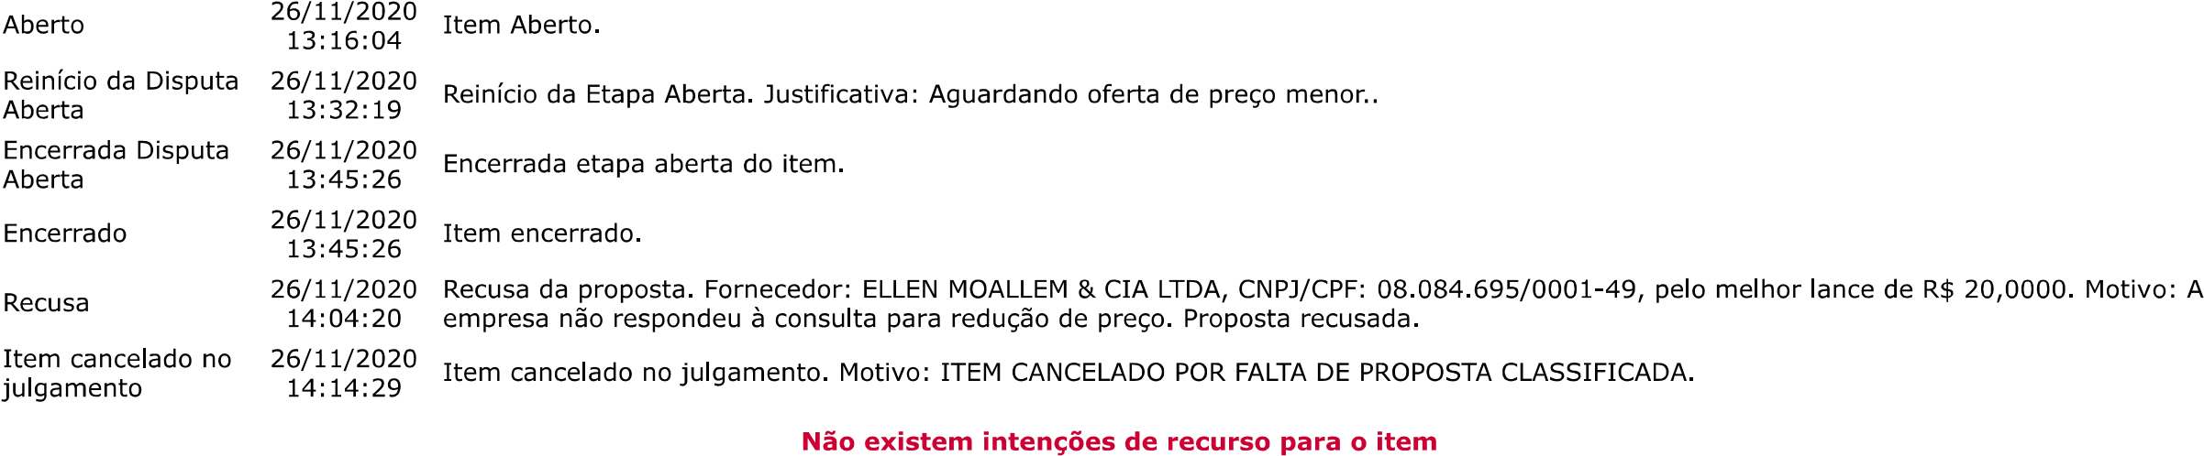
JFRJEOF202000272V01
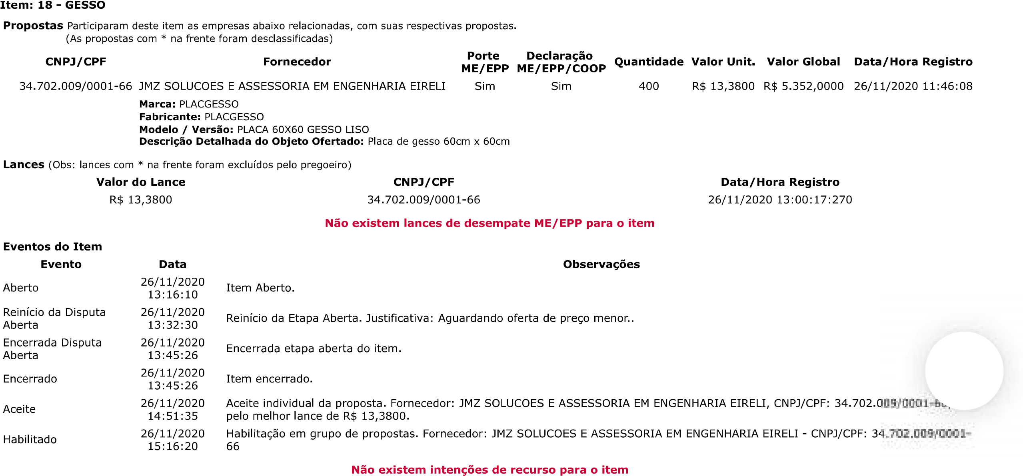
JFRJEOF202000272V01
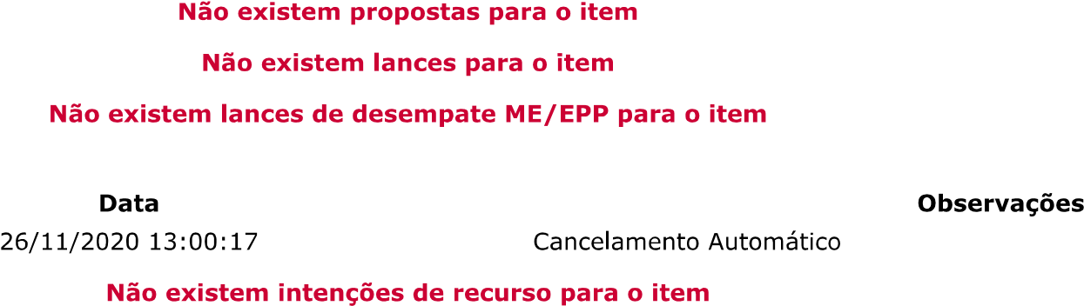

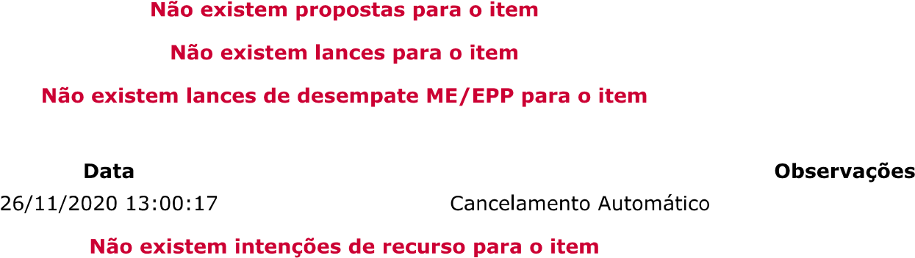
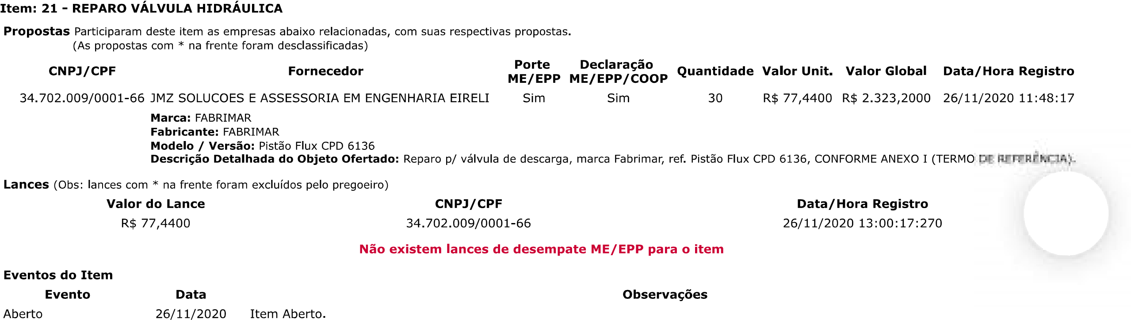
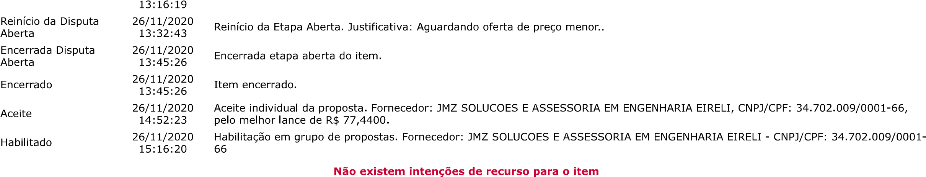
JFRJEOF202000272V01

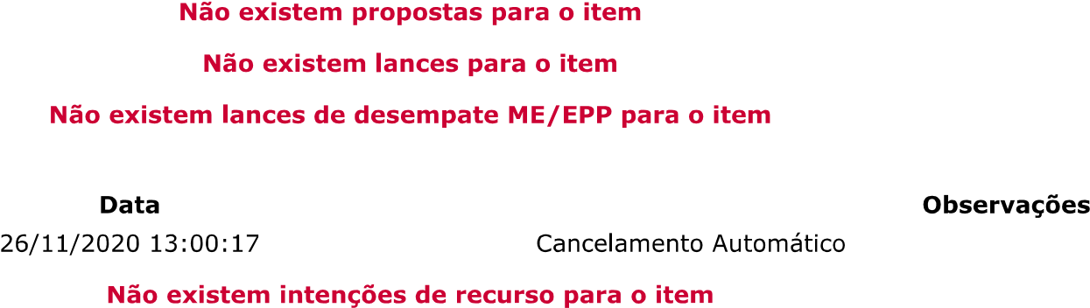

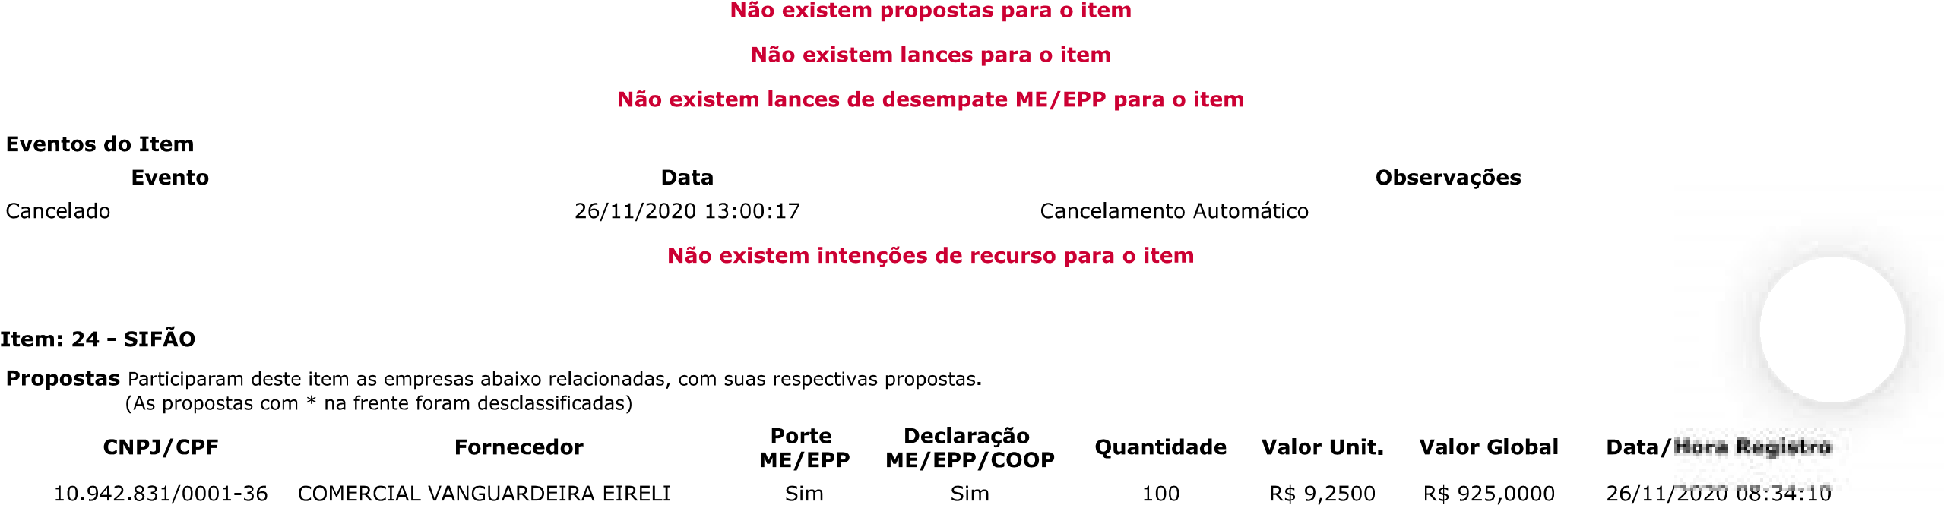
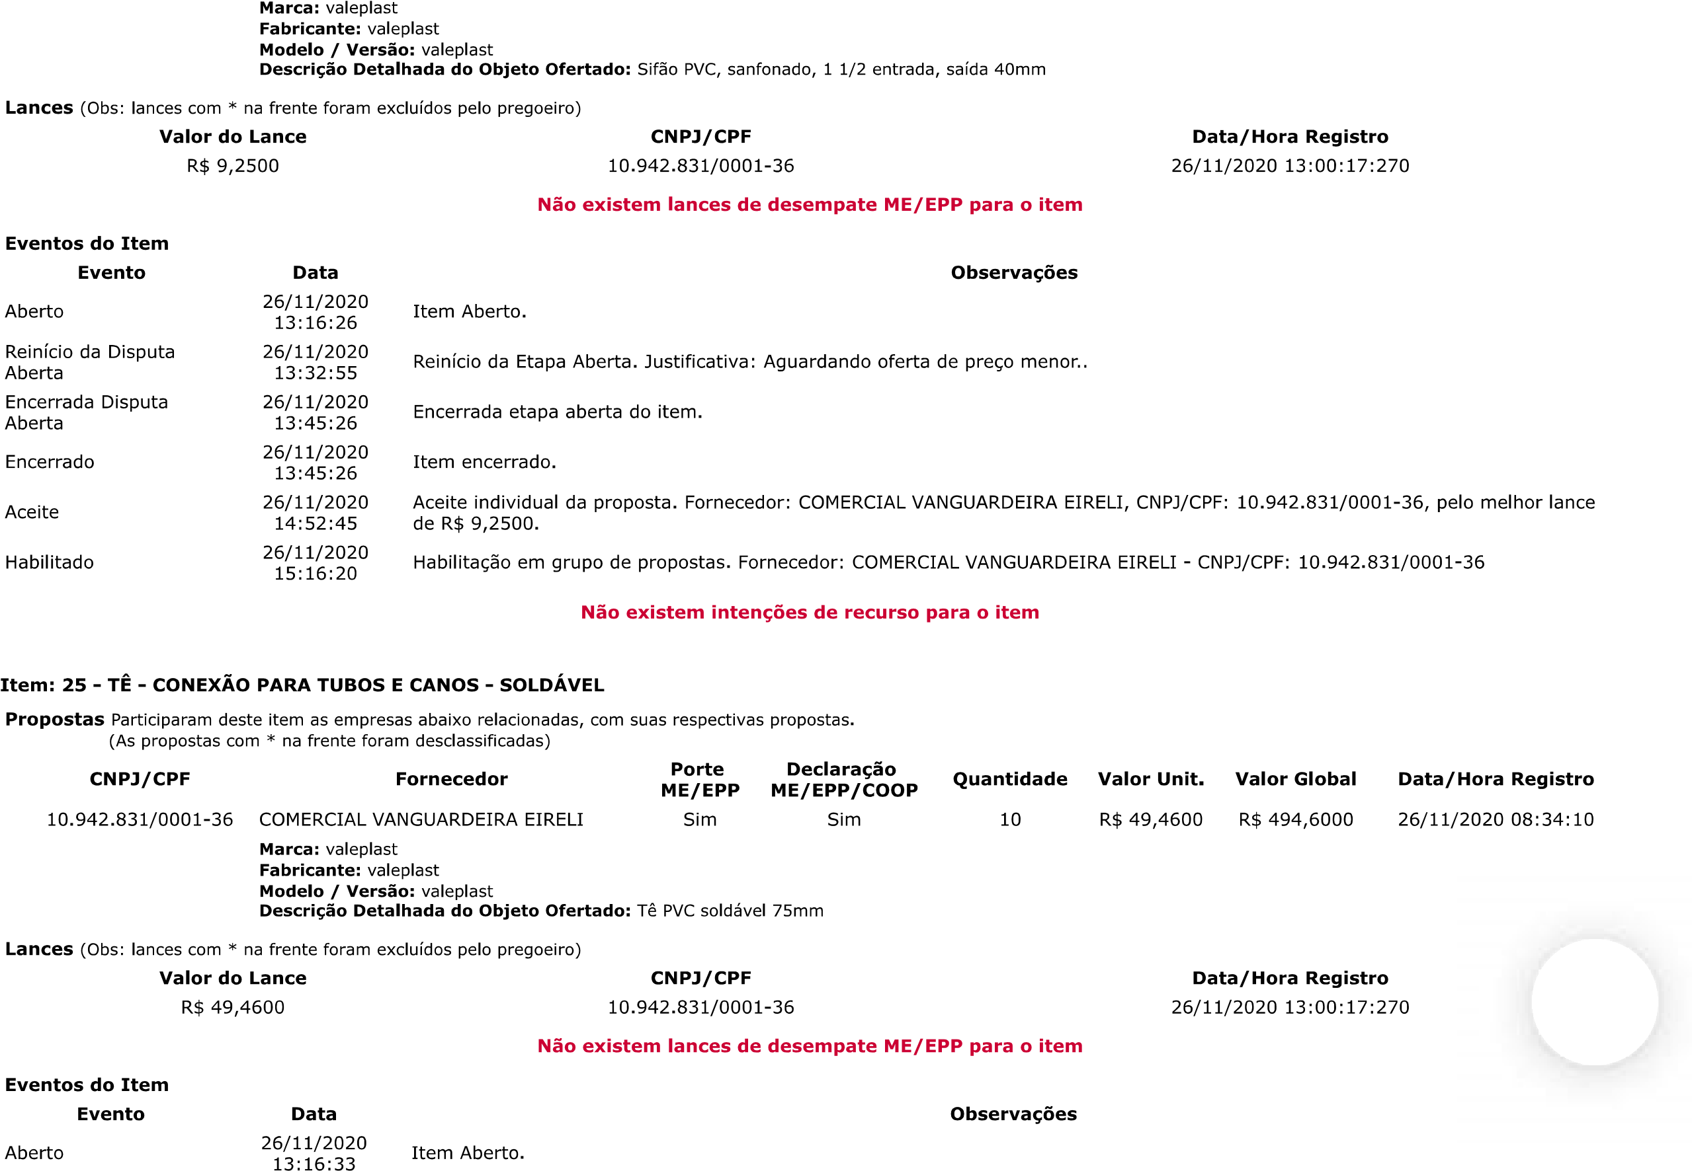
JFRJEOF202000272V01
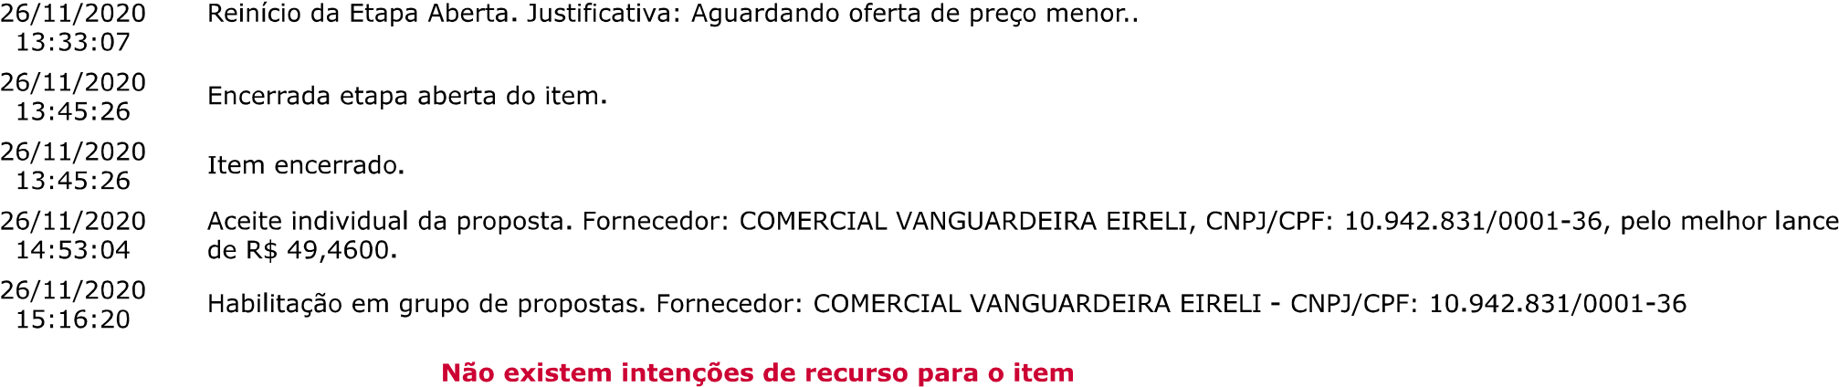
JFRJEOF202000272V01
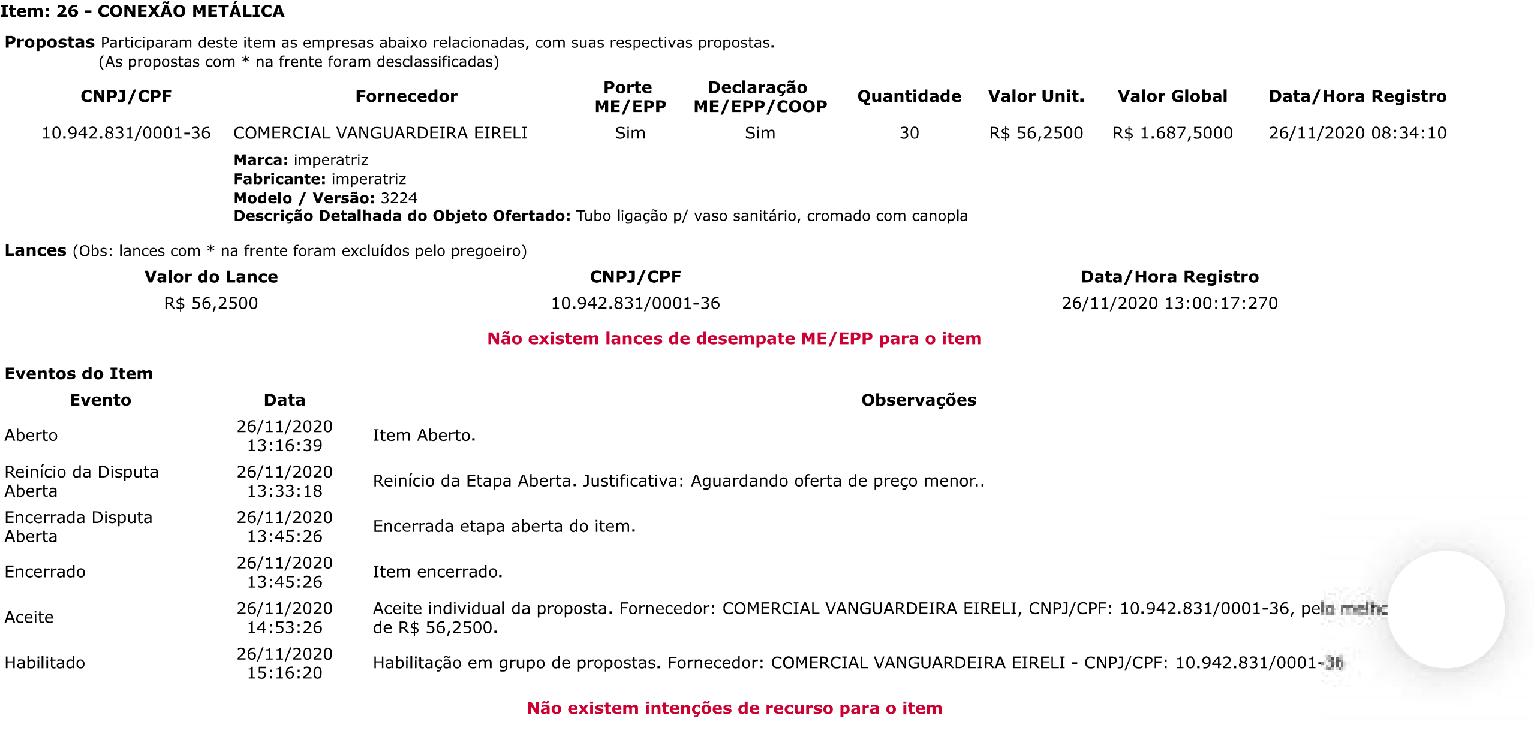
JFRJEOF202000272V01
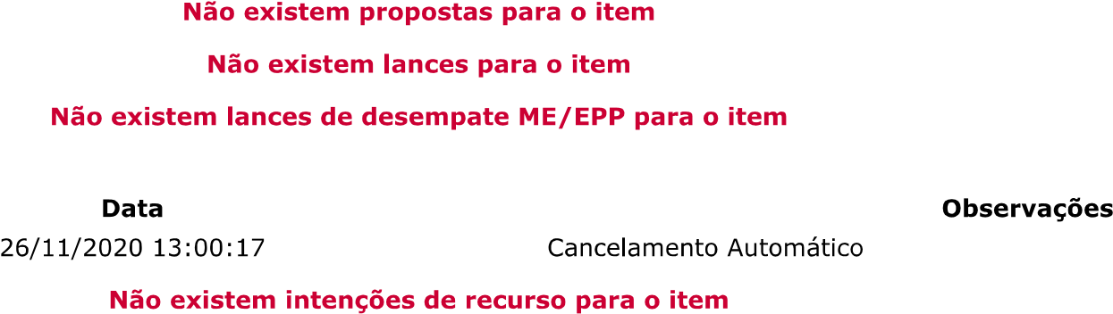

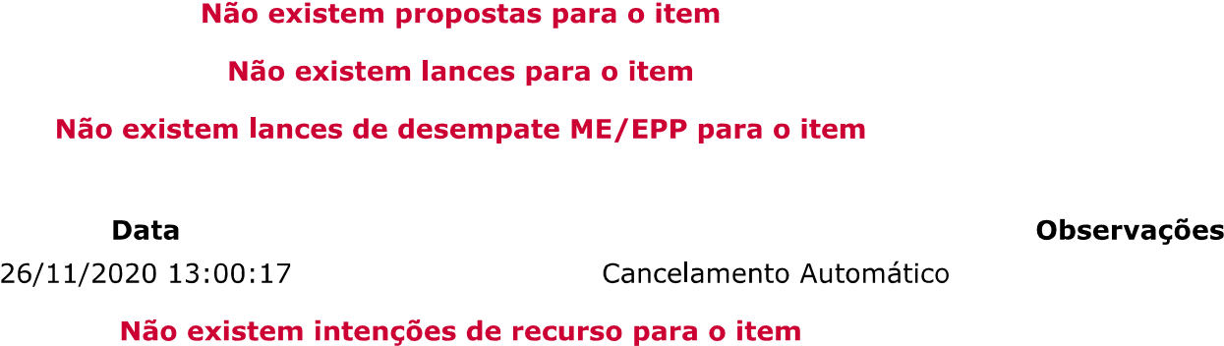

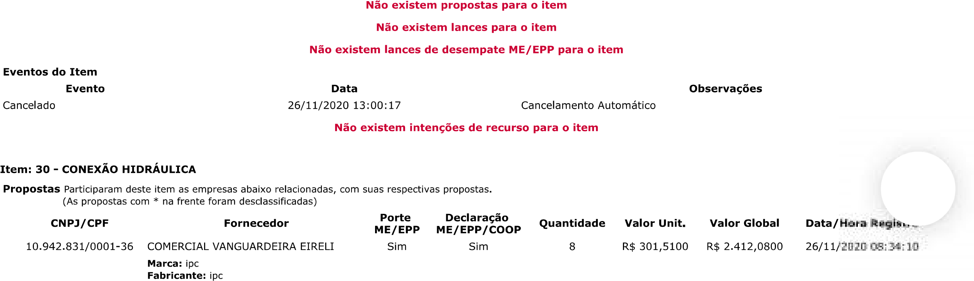
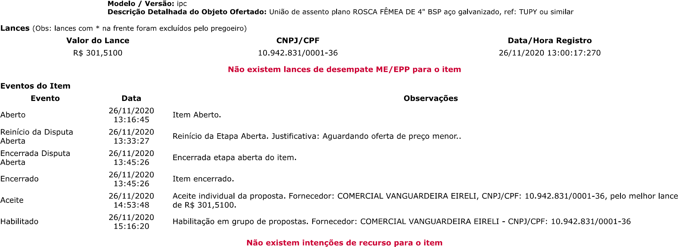
JFRJEOF202000272V01
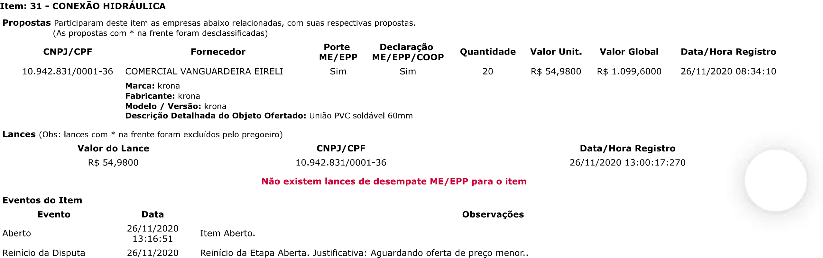
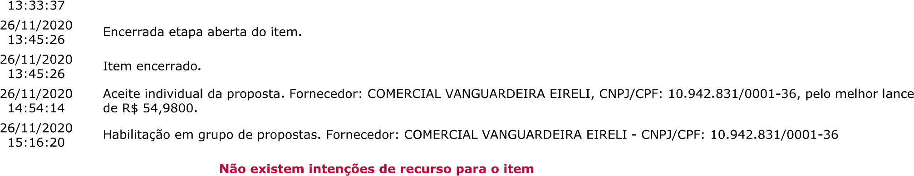
JFRJEOF202000272V01

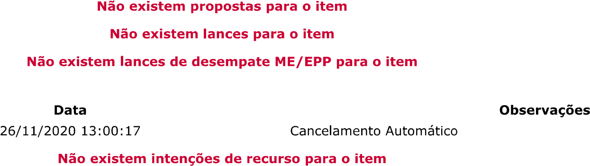

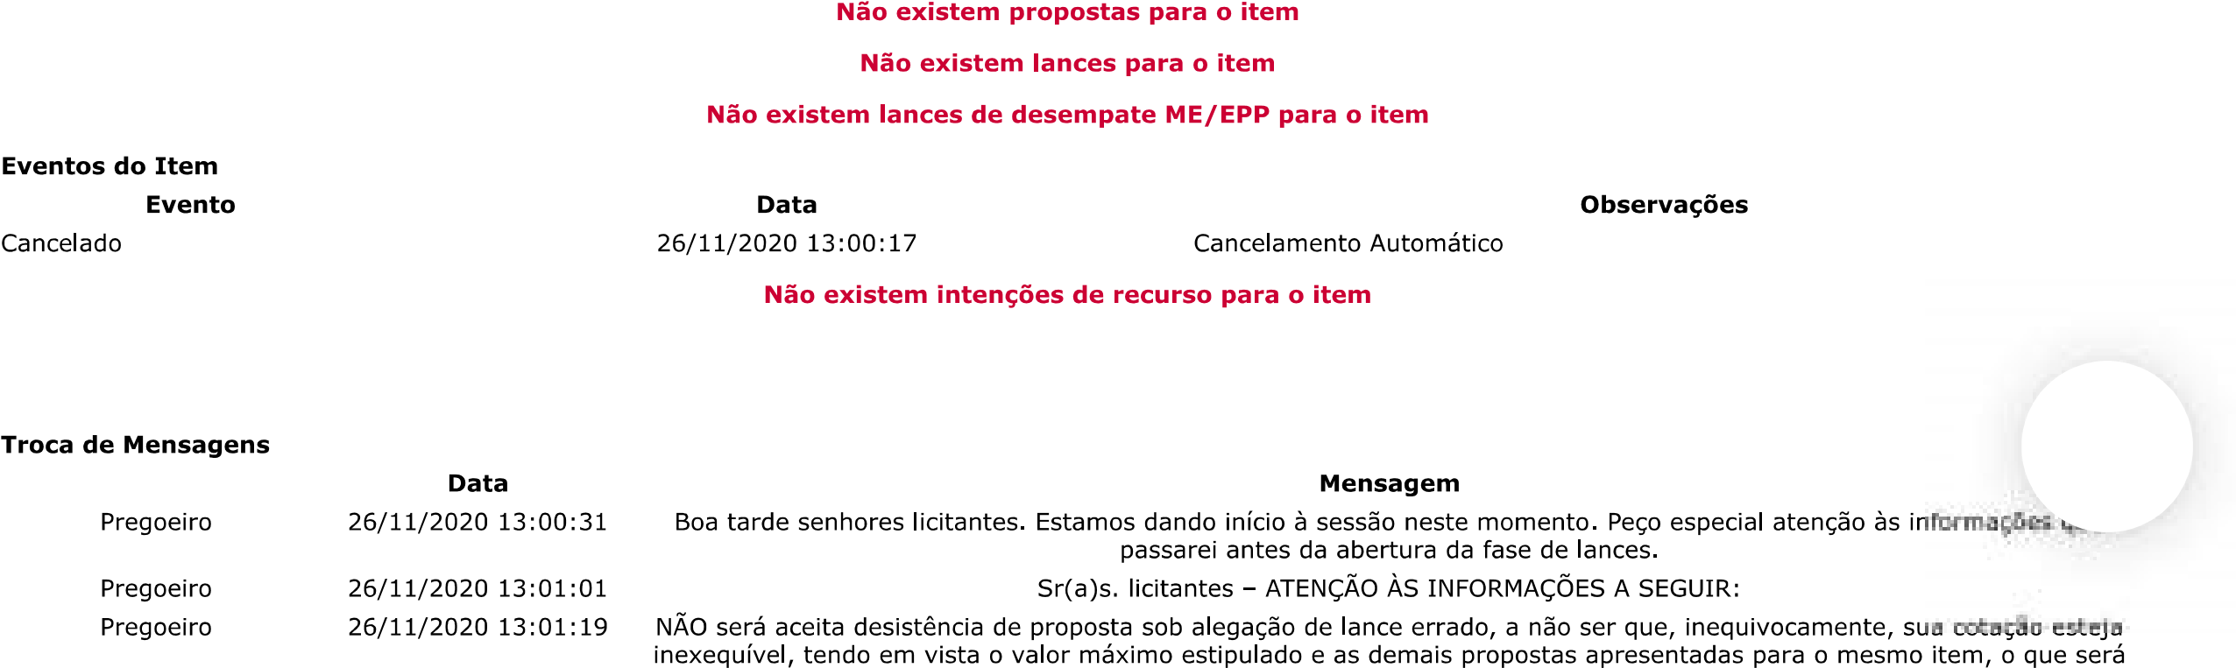
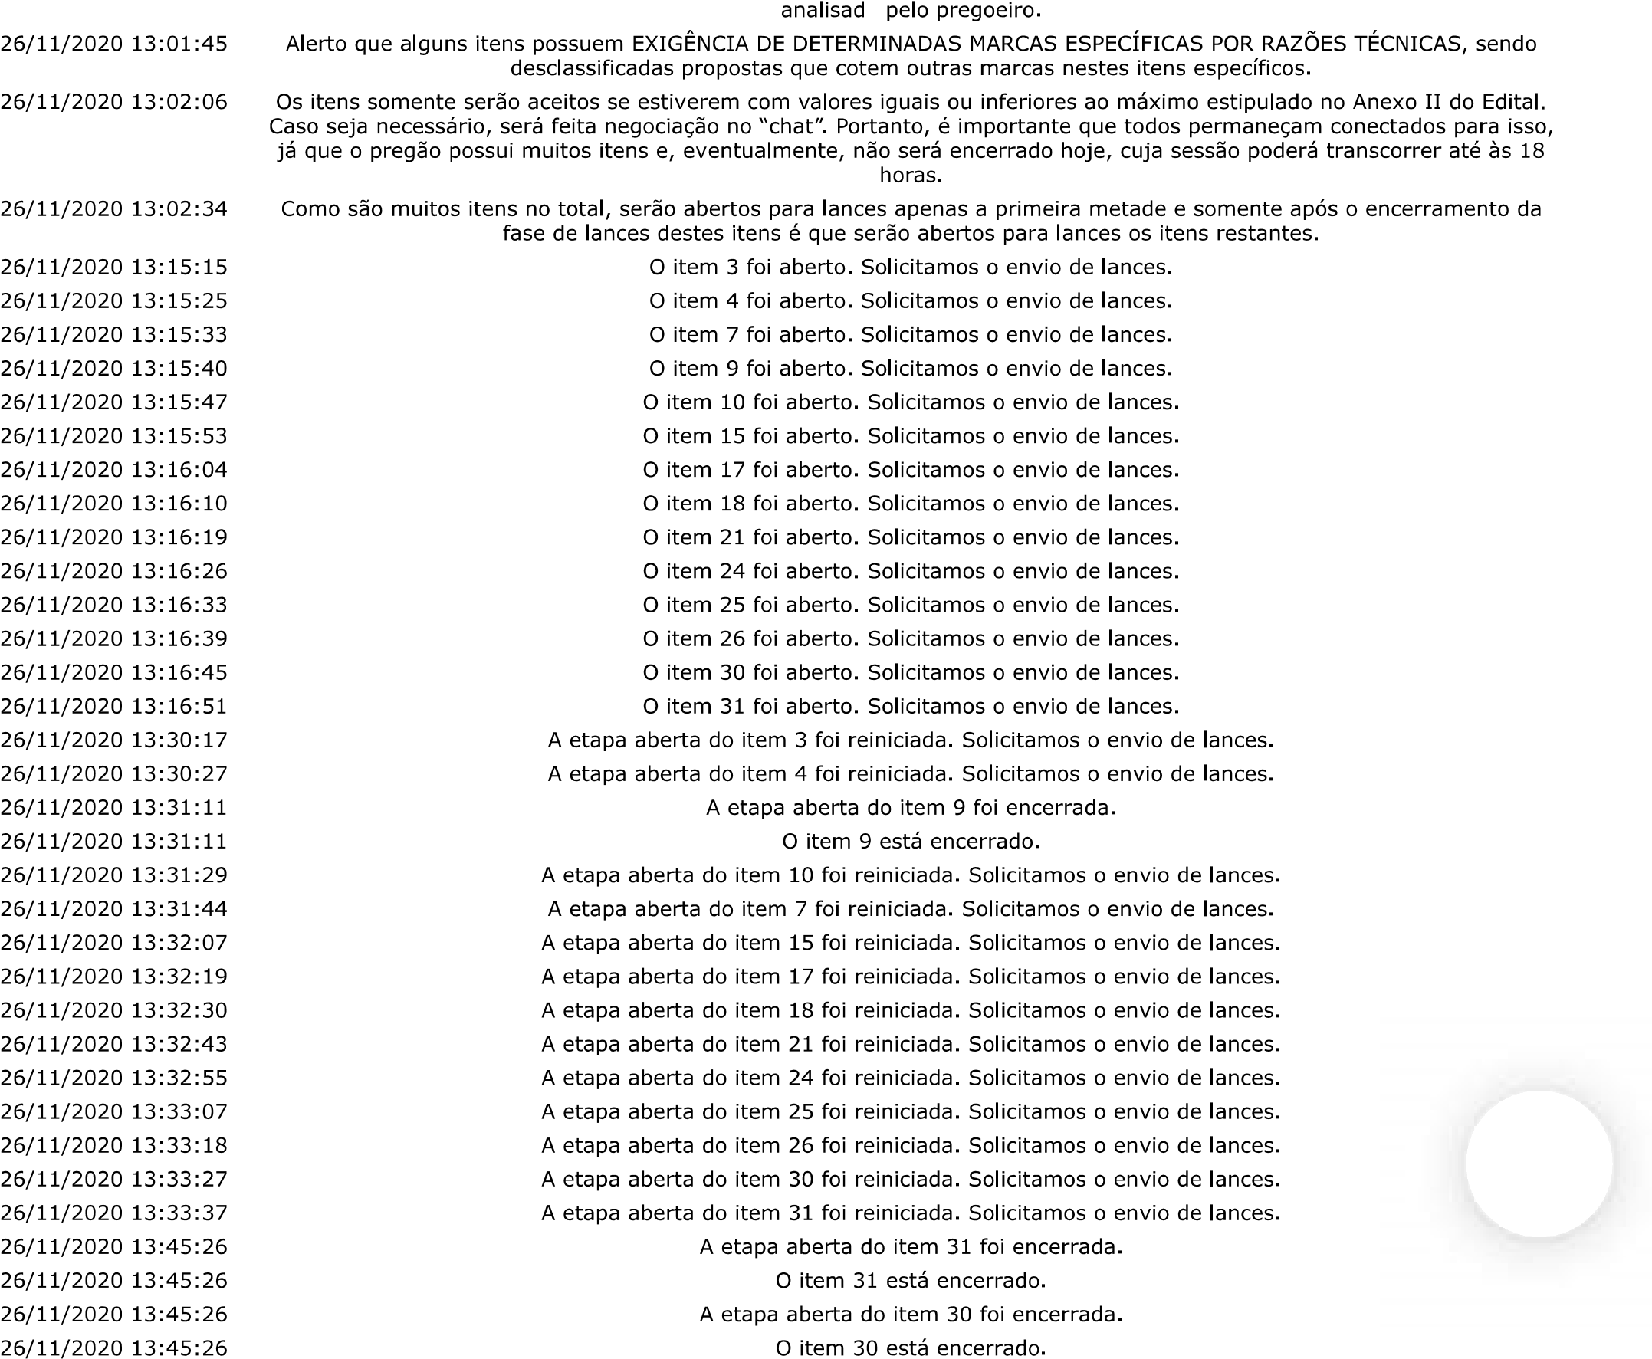
JFRJEOF202000272V01
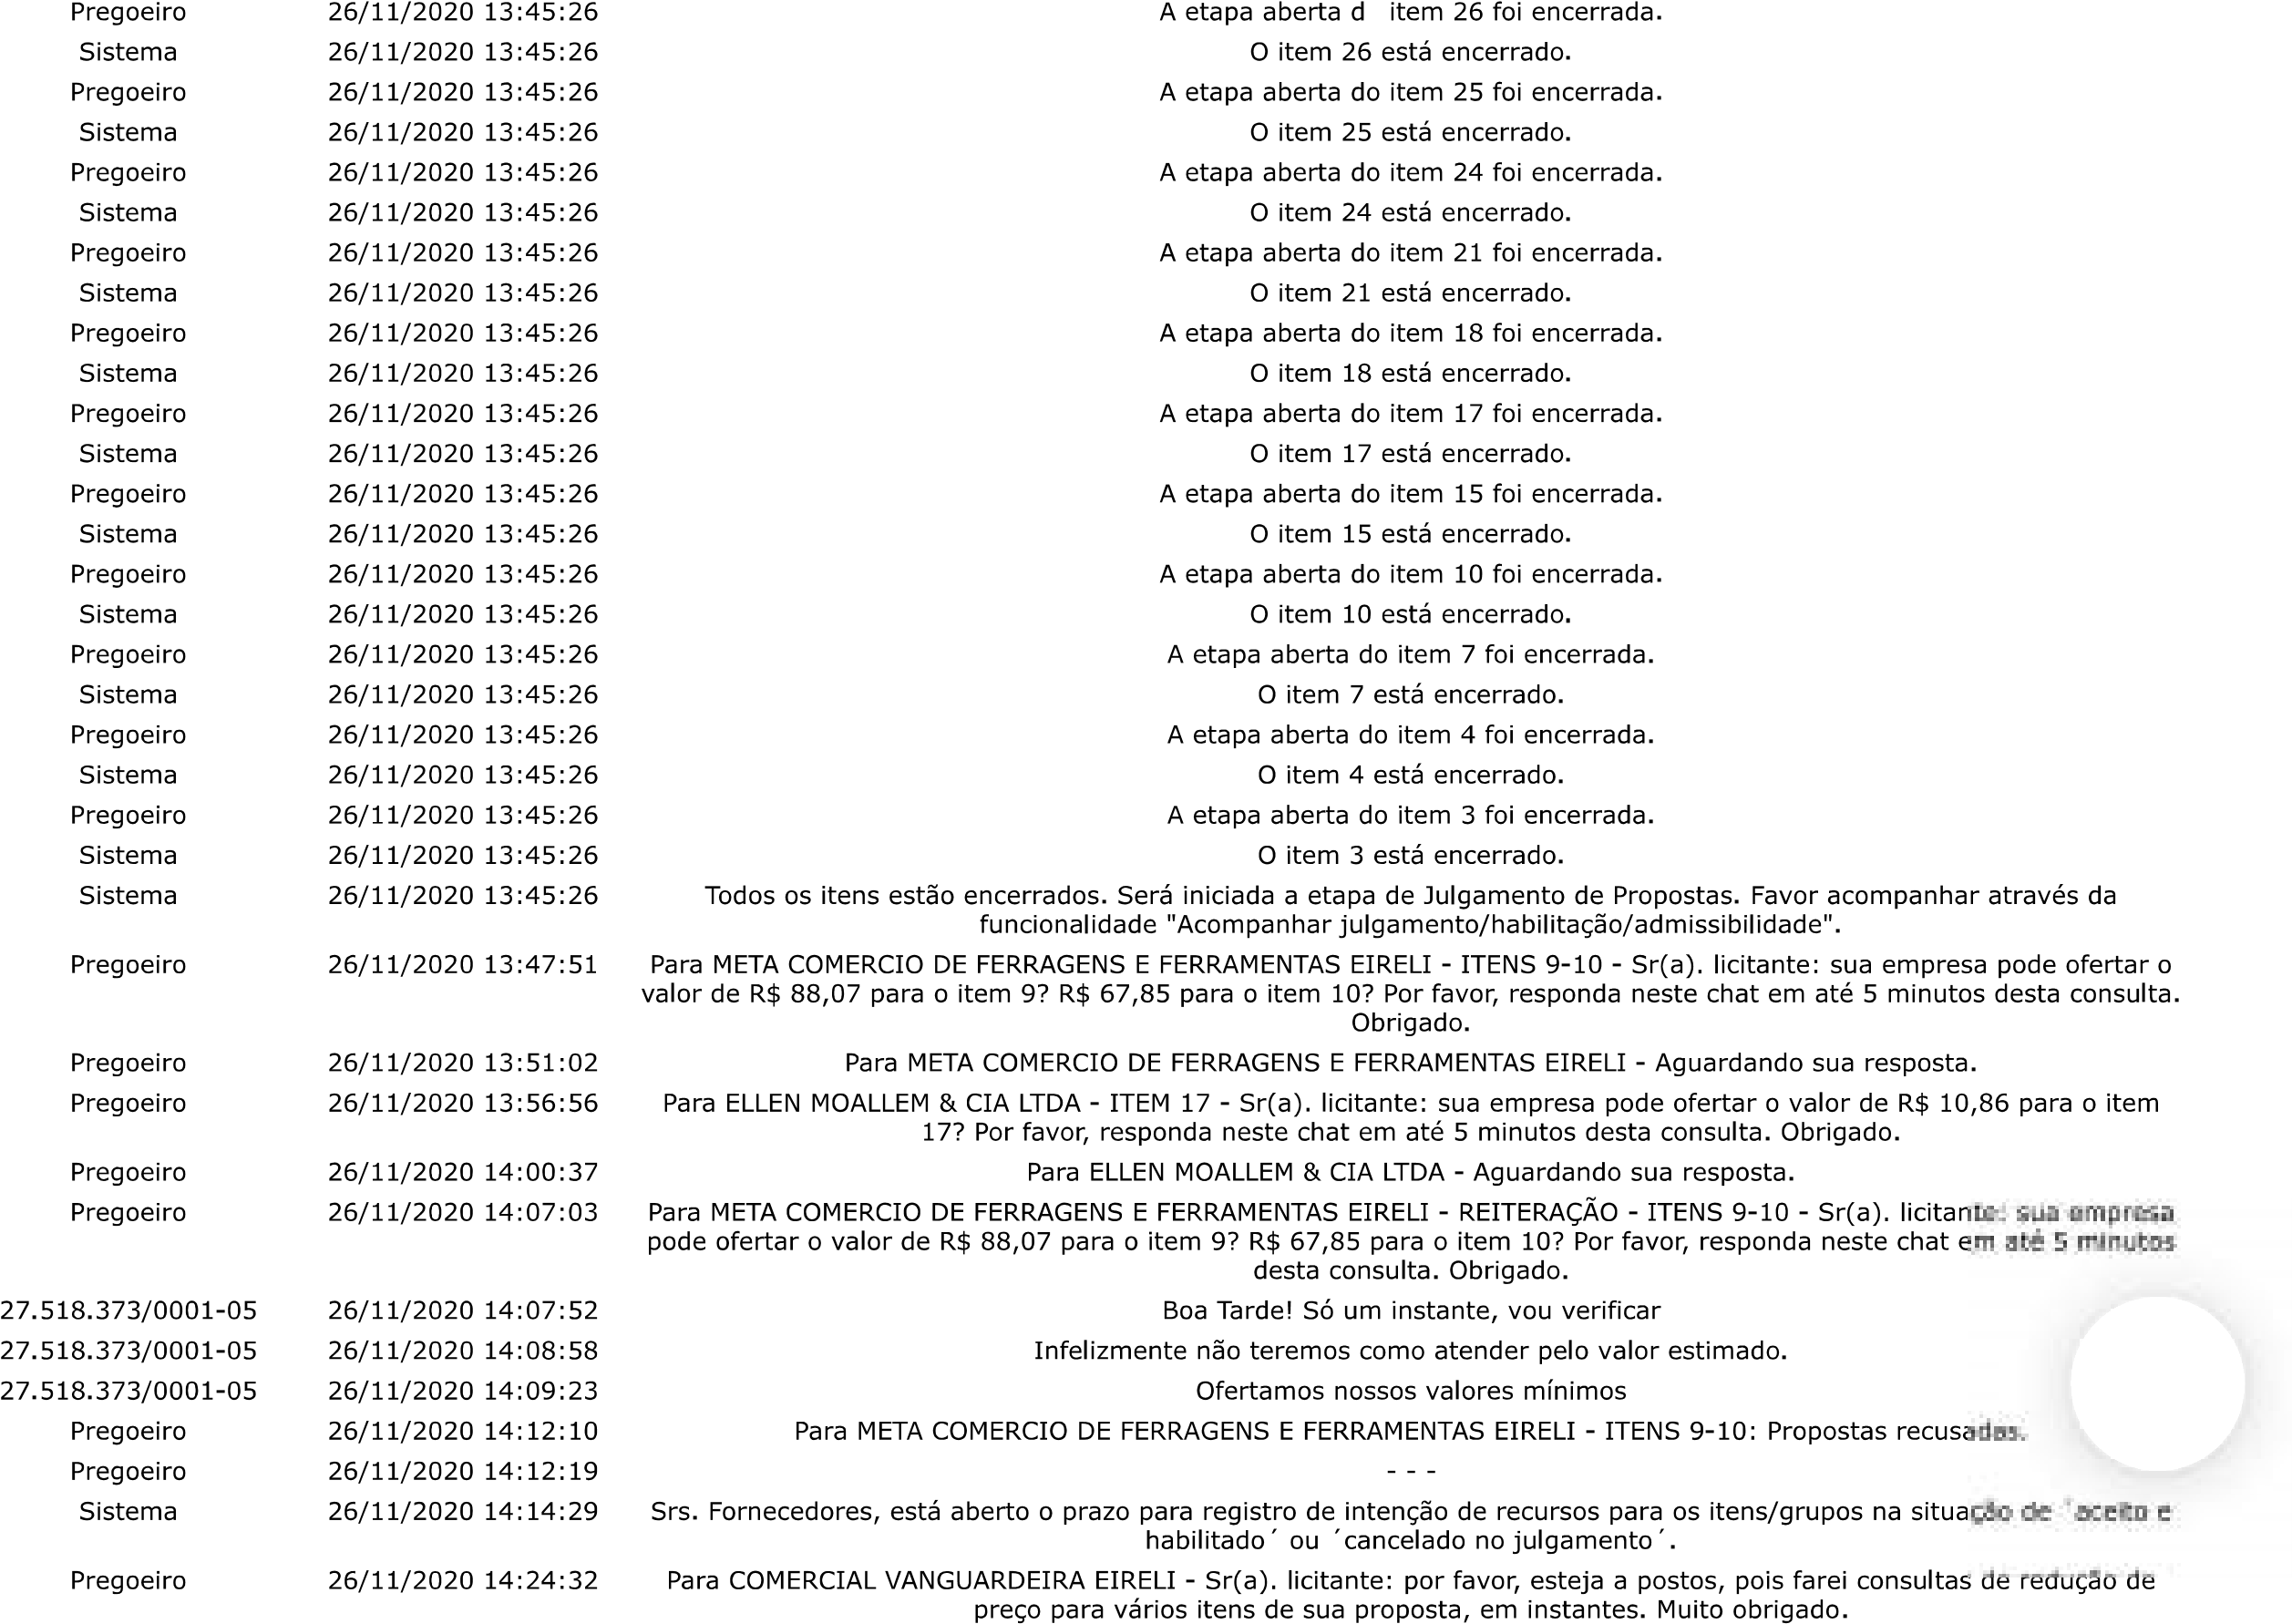
JFRJEOF202000272V01
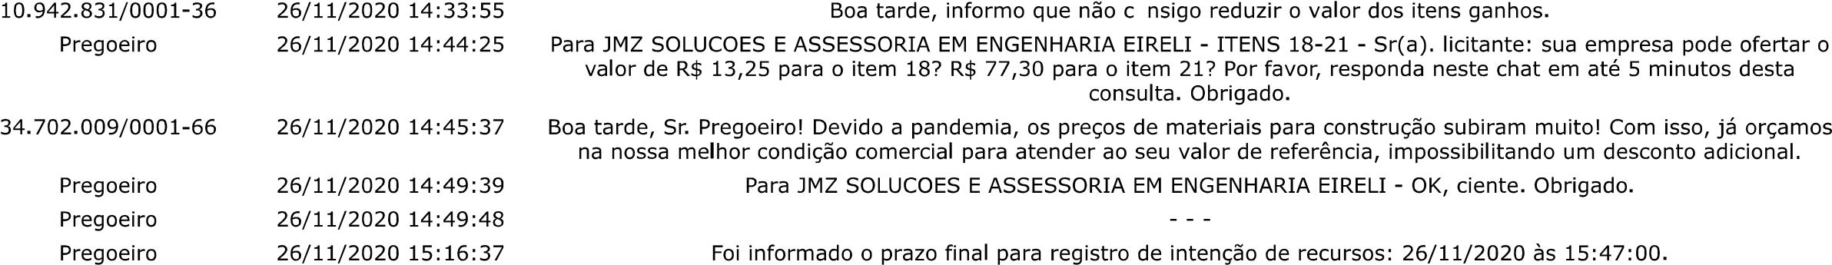
JFRJEOF202000272V01



