$%&’())*+,+%&-(./
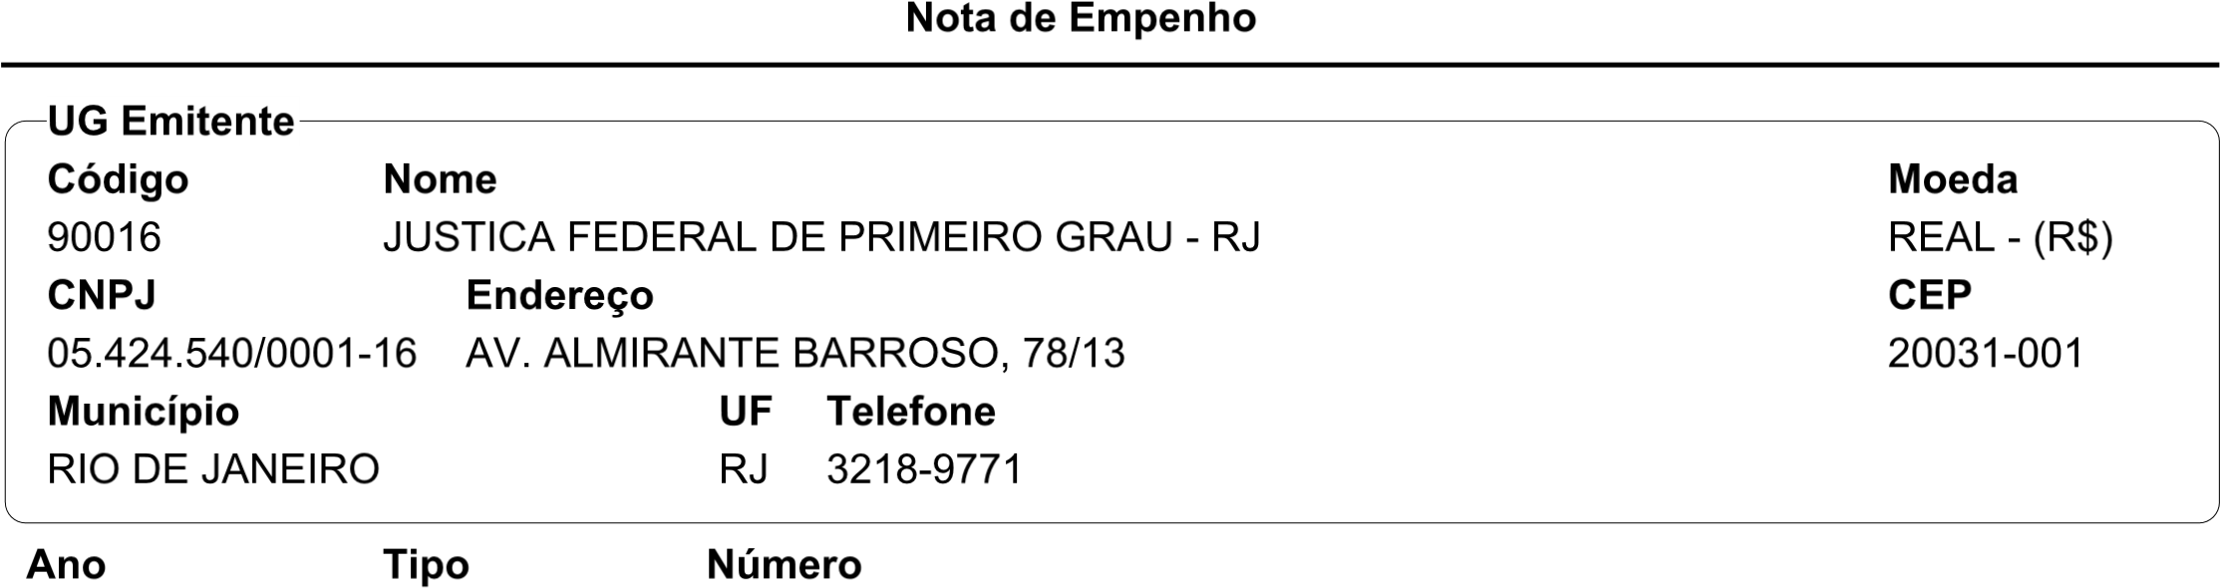


I> 7
!
K
N5M!O
Q
J
#
LM
NP
M
0
R ST"
7
U
Z
W 0X"Y
5
N
" V 5#
!
012
"
D’\]^_’]+
‘
U‘
7
U7
C::@>=@$E>@<,<DA;?<
42
012
N 2K
3
[
TV
4
Pe
" f
"#
4
[2
B@>E<D
U
$
4
e
A(]
Qf
!
T
:<
DA9$gEDIg<E< 7 AD8h>I=$,
<
0!
N
7
e#
3
@$D?>8<I>$@D
@8
Q 5 K
FH
TV
<a9$:$bcD?DC<;>@$<A?>@>=@$E>@<bcD$ B>b<:,DC?>C<I?<:9@E>I;>:B@>EcD
7 ‘:8@8 $? :$>
[ ! 2
,DI=D@C>>:B>,$=$,<bcD
PK"TV0"#"
7 7 9<:EC]^d./ 7
O " S2"
,DCB@<:I>;C>
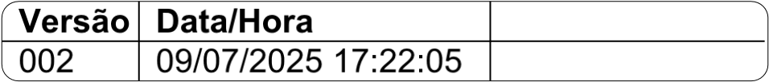S# TV
<-.(’/m*+ \(
$%&’())*+,+%&-(./
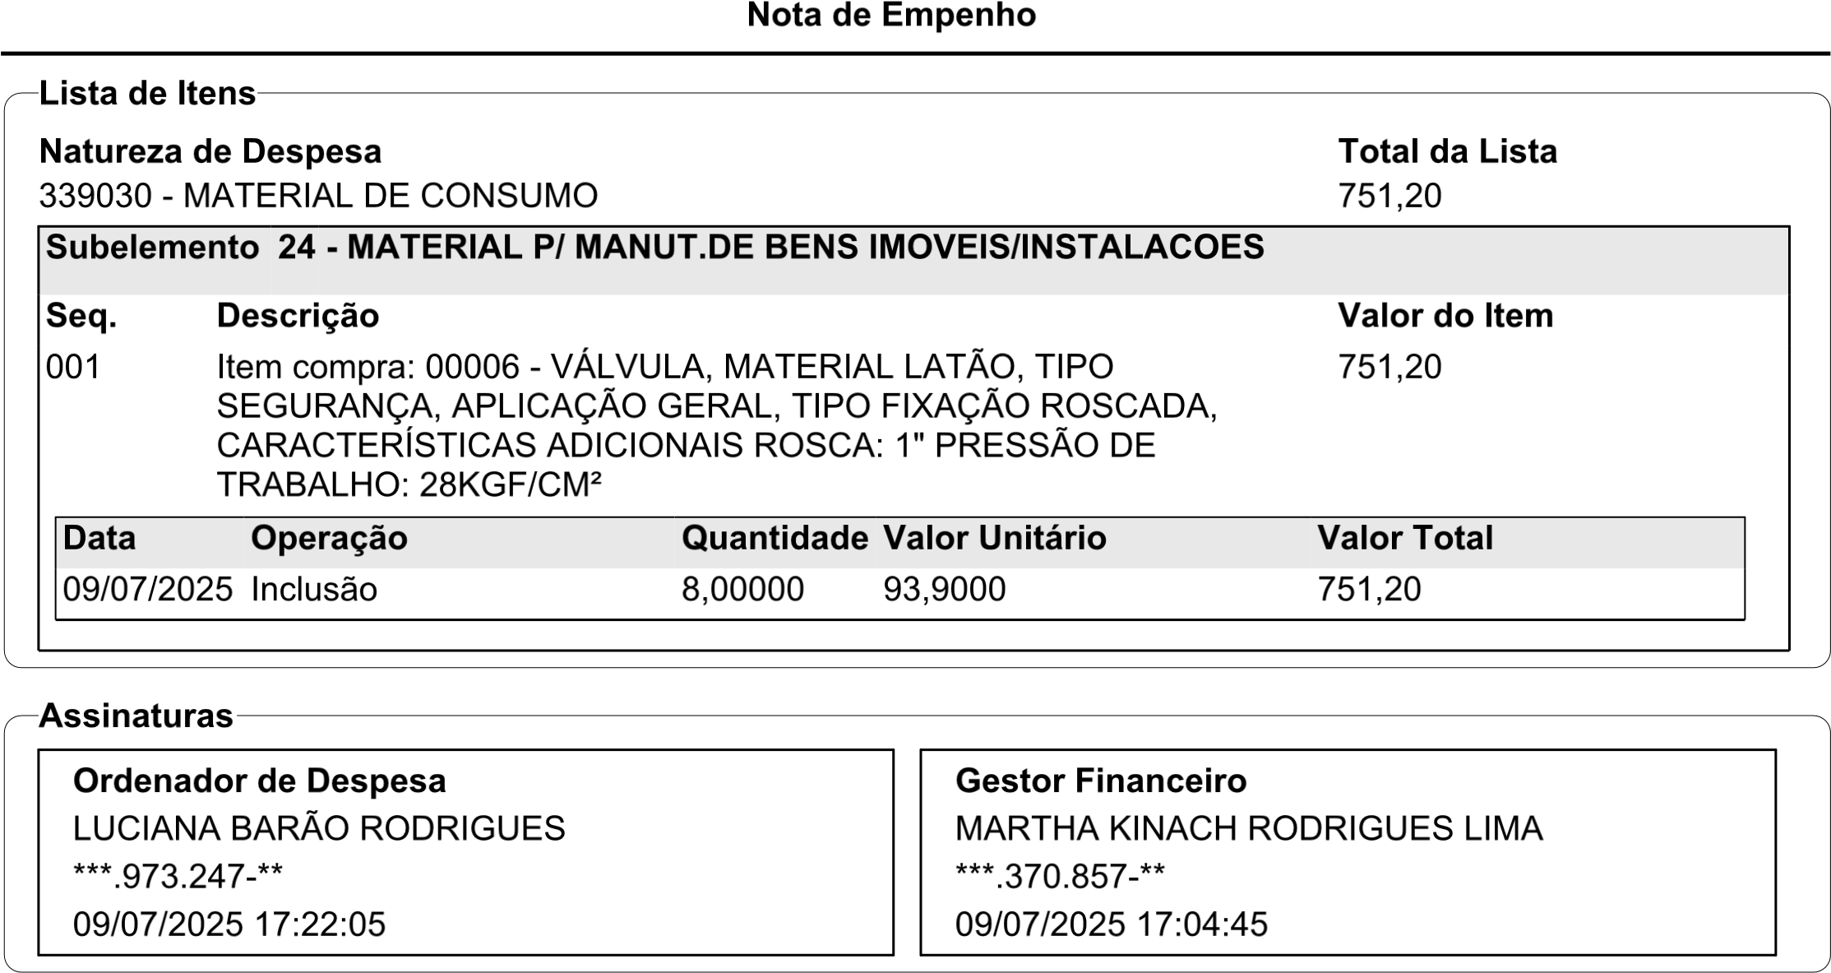
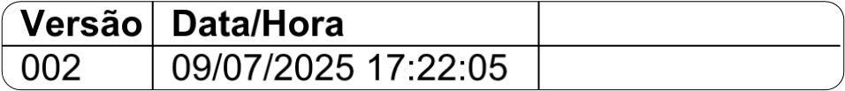L# ‘a
4-.(’/j*+ h(

