$%&’())*+,+%&-(./
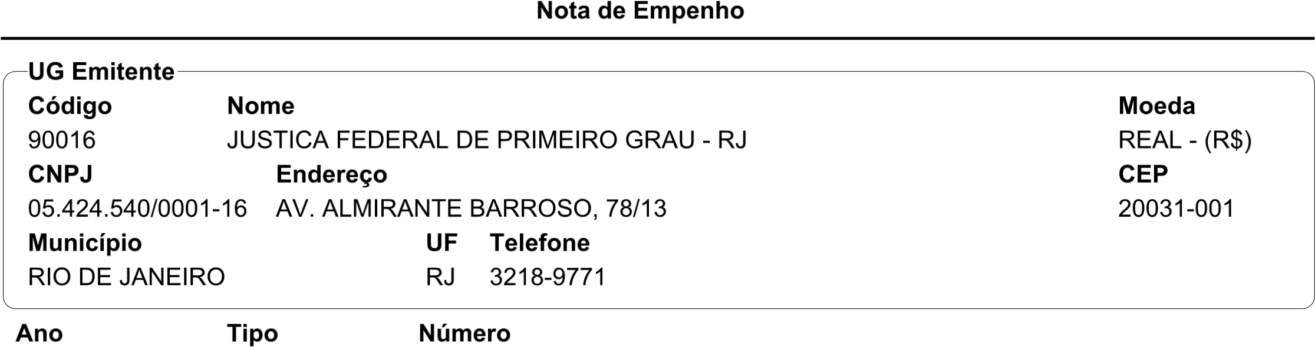


I> 77
!
K
N5M!O
Q
J
#
LM
NP
M
0
R ST"
7
U
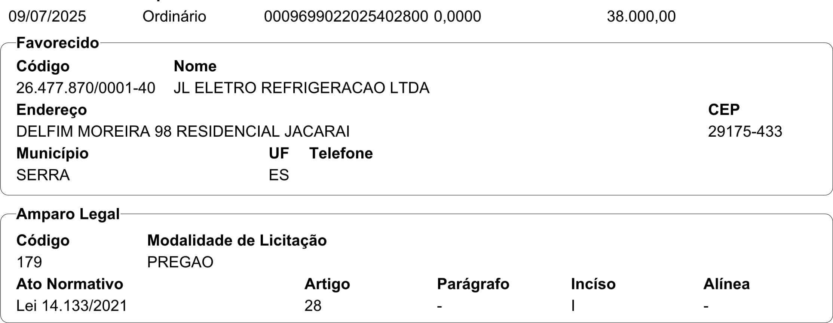
TV
<a9$:$bcD?DC<;>@$<A?>@>=@$E>@<bcD$ B>b<:,DC?>C<I?<:9@E>I;>:B@>EcD
7 ‘:8@8 $? :$>
[ ! 2
,DI=D@C>>:B>,$=$,<bcD
PK"TV0"#"
7 7 9<:EC]^d./ 7
O " S2"
,DCB@<:I>;C>
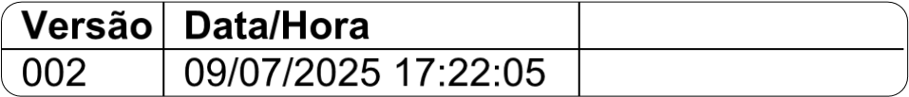S# TV
<-.(’/l*+ \(
$%&’())*+,+%&-(./
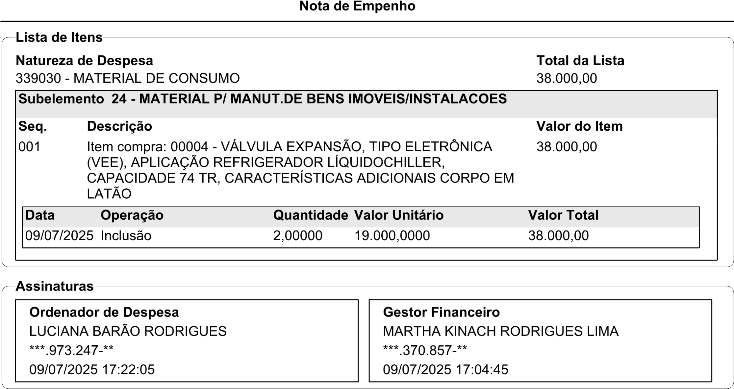
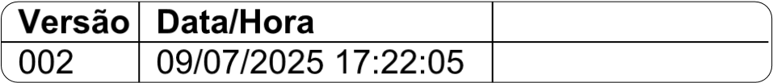M# _‘
4-.(’/k*+ i(

