$%&’())*+,+%&-(./
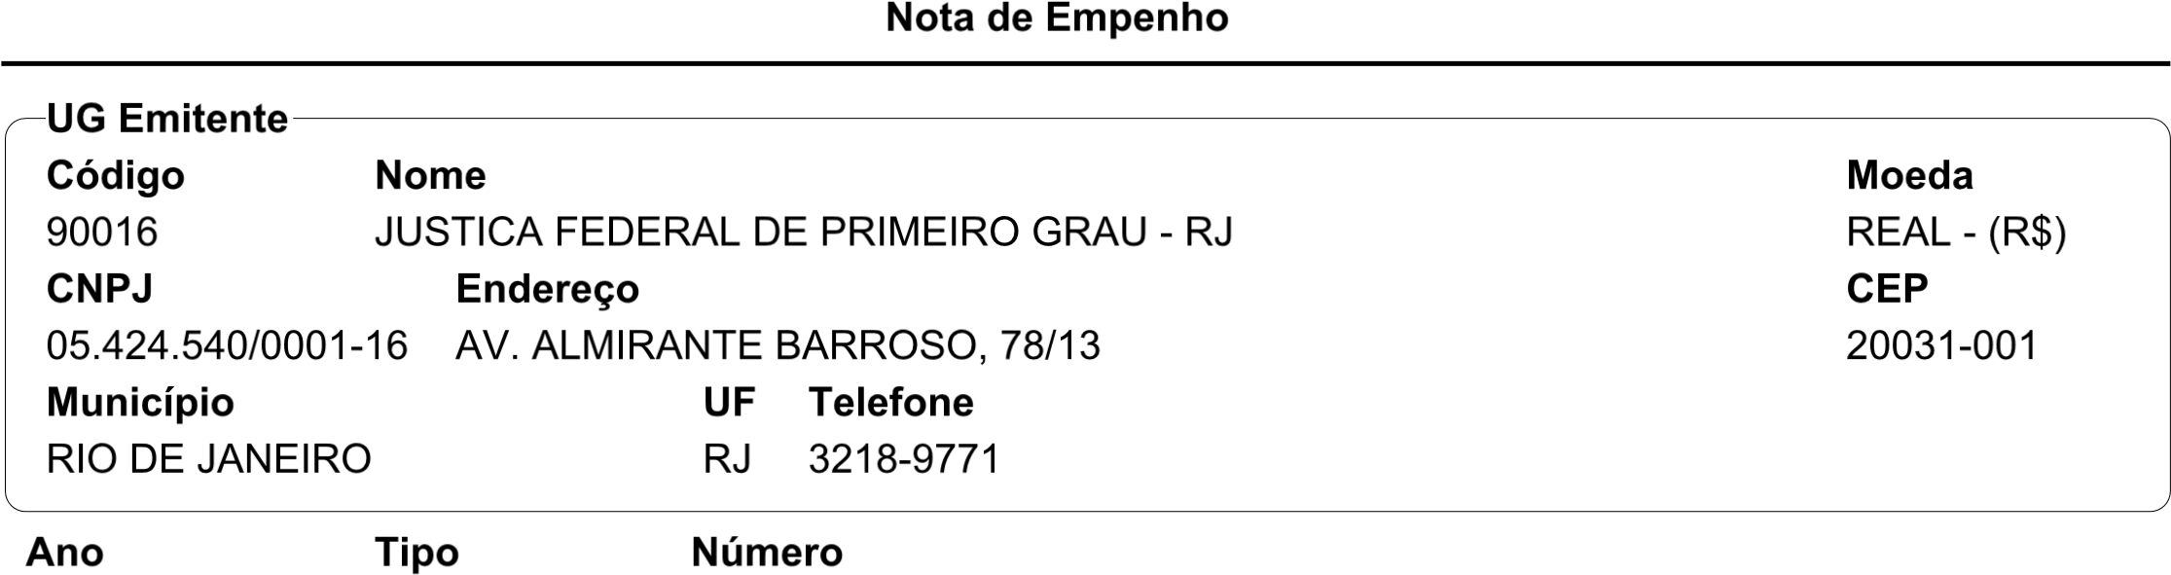


I> 7J
!
L
O5N!P
R
K
#
MN
OQ
N
0
S TU"
7
J
W 0X"Y
5
O
" V 5#
!
Z
012
"
‘
77
J‘
7
D’\]^_’]+
J
7
<
I<C<@$<:D<@>:?<,D:;<A;?
<
42
012
O 2L
UV
3
[
4
Qe
" f
[2
"#
4
B@>E<D
J
$
4
e
A(]
Rf
!
U
g>ADhD@$iDI;>7E9<@?<?D:=>@@>$@D
0!
O
JJ
e#
3
DED;<@?D
CE
:<
R 5 L
UV
<a9$:$bcD?DC<;>@$<A?>@>=@$E>@<bcD$ B>b<:,DC?>C<I?<:9@E>I;>:B@>EcD
7 ‘:8@8 $? :$>
[ ! 2
,DI=D@C>>:B>,$=$,<bcD
QL"UV0"#"
7 7 9<:EC]^d./ 7
P " T2"
,DCB@<:I>;C>
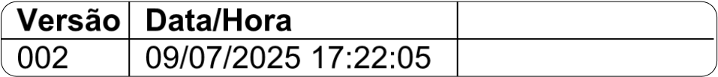T# UV
<-.(’/n*+ \(
$%&’())*+,+%&-(./
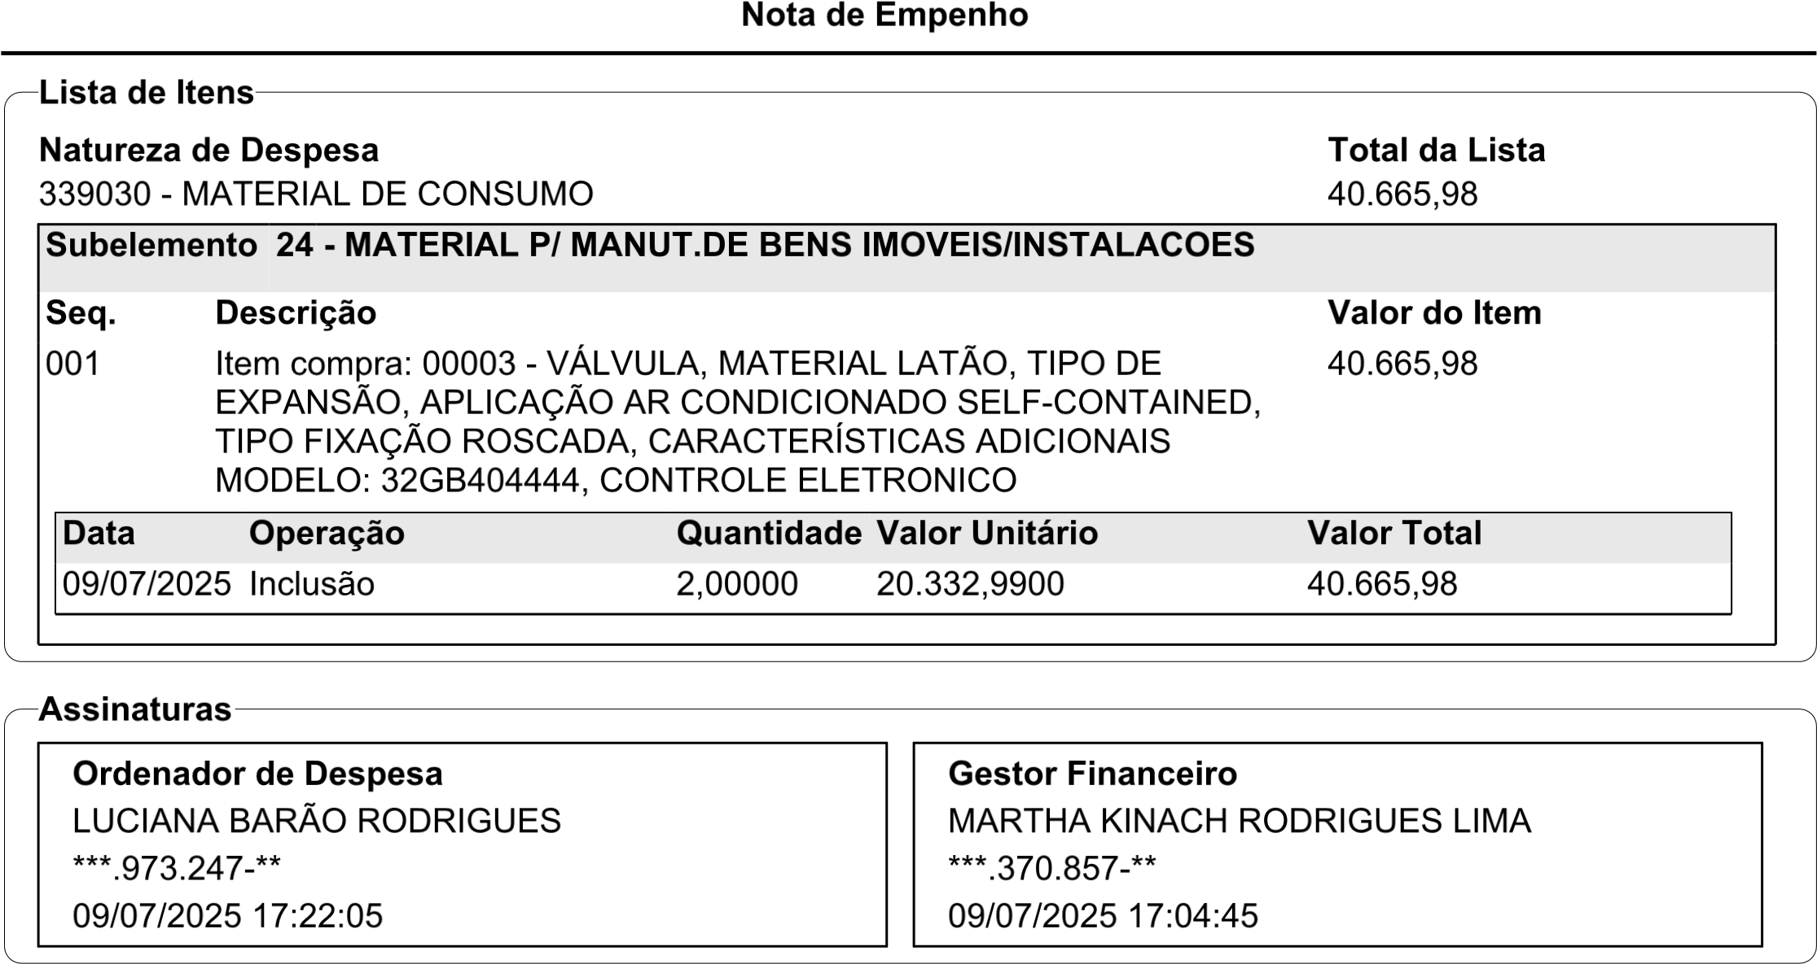
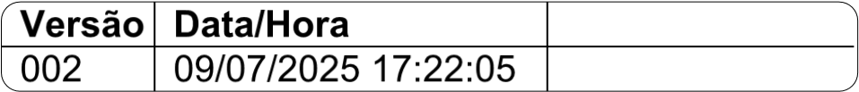N# \]
4-.(’/h*+ f(

