
JFRJCON202300056

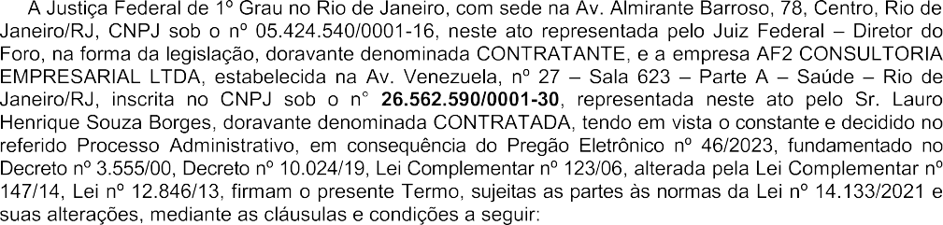

JFRJCON202300056
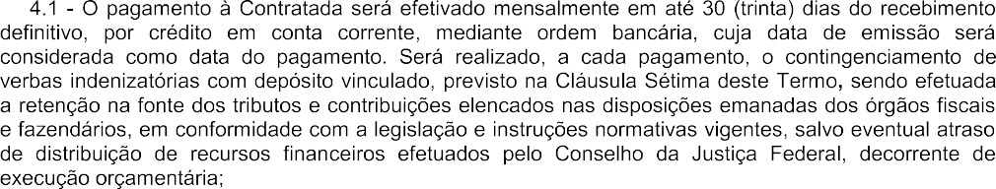
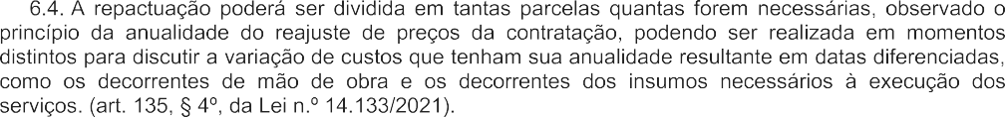

JFRJCON202300056

JFRJCON202300056
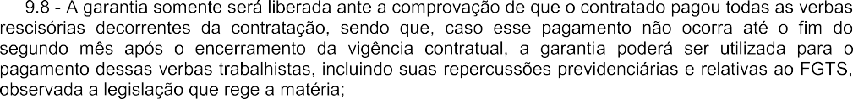
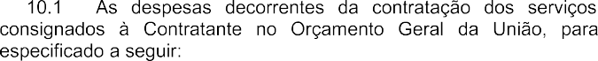
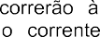


JFRJCON202300056

JFRJCON202300056
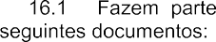

JFRJCON202300056

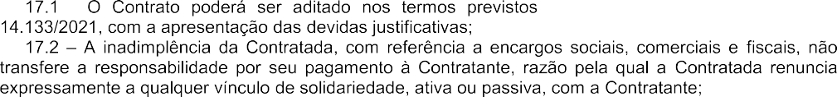



JFRJCON202300056









